 | CANTERBURY  TECHNICAL INSTITUTE
ASSESMMENT
CLUSTER 5 PROJECT DEMONSTRATION AND PRESENTATION
Unit Codes | Unit Title
Part I
ICTNPL413 | Evaluate networking regulations and legislation for the telecommunications industry
ICTNWK561 | Design enterprise wireless local area networks
Part II
ICTTEN622 | Produce ICT network architecture designs
ICTNWK612 | Plan and manage troubleshooting advanced integrated IP networks


Candidate Name: | Leonardo Matias Ciarcia
Candidate ID: | CIT20221062

Assessment Result – trainer use only
Assessment Task | Attempt 1 |  | Attempt 2 |  | Attempt 3 |  | Attempt 4 |  | Date
AT 1 | S ☐ | NYS ☐ | S ☐ | NYS ☐ | S ☐ | NYS ☐ | S ☐ | NYS ☐
AT 2 | S ☐ | NYS ☐ | S ☐ | NYS ☐ | S ☐ | NYS ☐ | S ☐ | NYS ☐
AT 3 | S ☐ | NYS ☐ | S ☐ | NYS ☐ | S ☐ | NYS ☐ | S ☐ | NYS ☐
AT 4 | S ☐ | NYS ☐ | S ☐ | NYS ☐ | S ☐ | NYS ☐ | S ☐ | NYS ☐
Assessor Initials |  |  |  |  |  |  |  |  | -
Overall result – All Assessment tasks must be deemed Satisfactory to award a Competent Outcome
Assessor Signature – sign at the overall result stage only
Name: Signature (initials are acceptable): Date:

Student Declaration/Signature
I understand the consequences of plagiarism/cheating and confirm that this is my own work and I have acknowledged or referenced all sources of information I have used for the purpose of this assessment.

Name: Signature (initials are acceptable): Date:
Leonardo Matias Ciarcia LMC 20/09/2025

Assessment Evidence
Instructions to assessors:
These following sections are to be used to record the students’ responses to the variety of assessment tasks as listed below. Each Assessment Task should include space to mark a Satisfactory or Not Yet Satisfactory outcome for each question or section. When performing assessment, you must ensure that:
- Each item is assessed against the criteria in accordance with the Marking Guide utilizing the Rules of Evidence and the Principles of Assessment.
- An assessment result is indicated by checking the appropriate box.
- Only result the UoC after all assessment parts are completed and satisfactory.
- Detailed feedback is provided to the students.
- The candidate is advised of the assessment result.
- All required signatures and dates are completed.
Instructions to Students:
- All work MUST be entirely of the candidate.
- Read the instructions for each question very carefully.
- Responses/ required evidence must be answered in the spaces provided. For any activities requesting extra evidence such as research reports, ESSAY reports, etc. The student must attach work formatted in double space, Arial 12 pts and black font.
- All activities must be addressed correctly to obtain competence for the unit of competency.
- If the candidate doesn’t understand the assessment, they can request help from the assessor to interpret the assessment.
- To achieve competence students must satisfactorily complete all components of the assessment.
- For re-assessment and academic appeals, please see the student handbook for details.
Candidates must complete the following items and submit all evidence as stipulated in the instructions of each Task.
Assessment: Cluster 5 Project Demonstration and Presentation | Assessment type | General Instructions | Required Evidence | Submitted
Week 26 | Observation | Perform tasks as per the Class Activity in a workplace or simulated environment. | Satisfactory completion of required tasks and inclusion of appropriate screenshots. | ☐
 |  |  |  | ☐
Week 26 | Role Play | Perform tasks as per the Class Activity in a simulated environment. | Satisfactory performance of own or assigned role during the role play. | ☐
Week 26 | Project | Complete the tasks as outlined in the Assessment Tool, ensuring all requirements of that assessment part are addressed. | Satisfactory completion of required tasks and inclusion of appropriate screenshots where required.  Completed report. | ☐

Reasonable Adjustment
Where reasonable adjustment has been made to this assessment the assessor must evidence the adjustment (including mapping) and ensure that all UoC criteria are met in full. Any adjustment to assessment activities must be approved by Senior Management.
Was reasonable adjustment included in any part of this assessment? ☐ Yes ☐ No
If yes, what reasonable adjustment methods were used?

Has mapping been provided to show the assessment maintains compliance? ☐ Yes ☐ No

Cluster 5 Practical Activity –Week 26: Project Demonstration and Presentation

This is the end of cluster Practical Demonstrations for cluster 5.
These practical activities require you to complete the associated practical/ observation and role play tasks in class/ ICT Lab by participating and completing your part in the class Workshop/Practical Activities and Industry client project including liaising and collaborating with the client to finalize client needs regarding the network management – troubleshooting and monitoring.

Question Number | Question/Response | S | NYS
 | To complete this week’s activity, you are required to complete the industry client’s project at the appropriate site. Evidence required include a summary of portfolio that you attended and participated in the class workshops and completed all allocated tasks and practical activities by your trainer.
 | Cluster Practical Demonstrations
 | You must participate in the review workshop and complete the practical demonstrations of your cluster 5 project .  Guiding Details of Requirements:  - Your project requirements will correspond to your enrolment date.  - Those who started from phase 1, will complete all demonstrations from phase 1 to phase 4.  - Those who started from phase 2, will complete all demonstrations from phase 2 to phase 4.  - Those who started from phase 3, will complete all demonstrations from phase 3 to phase 4.  - Those who started from phase 4, will complete all demonstrations for phase 4.  - Those who started from any phase other than phase 1, will complete all remaining demonstrations of the project during the next cycle of delivery for Cluster 5 to complete all requirements for cluster 5. | ☐ | ☐
PRACTICAL DEMONSTRATIONS
(Week 26)

All students

Considering the client requirements of the Assessment Tasks 3 and 4, you are required to:
- Set up the live prototype of the network solutions you have proposed and
- Demonstrate the planning, managing, and implementing troubleshooting and monitoring strategies to ensure reliability and performance on advanced integrated internet protocol (IP) networks.

 | - Set up the live prototype of the network solutions you have proposed.  Your set up in the lab will include at minimum:  1. An ISP CPE  2. Network switch  3. An AP  4. Cable connected workstations  5. Wireless/mobile devices  6. Any other end device from client requirements.  7. WAN and LAN connections and configuration of the required services on the network  8. Network Troubleshooting and Monitoring.  Tips:  This practical activity must be completed in the ICT/ Telecommunications laboratory.  Your choice of your specifications and configurations, is to be based on the project scenarios completed in class and the project requirements of the Assessment Task 4 project in the previous weeks.  Required: You must include screenshots/ pictures (and/ or videos) of your demonstration’s activities.  Response:  Prototype represented in the practical  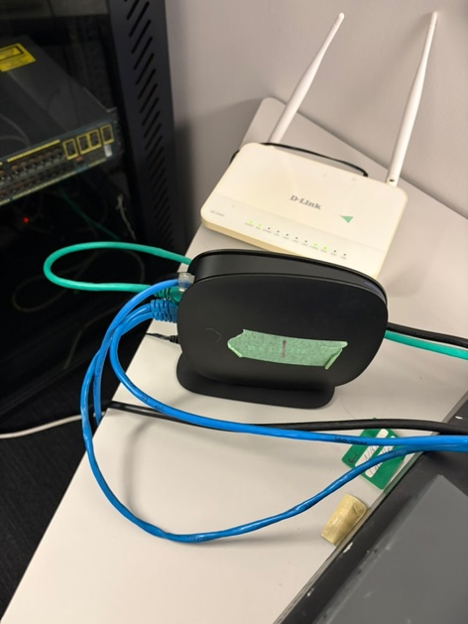  Home router and the AP  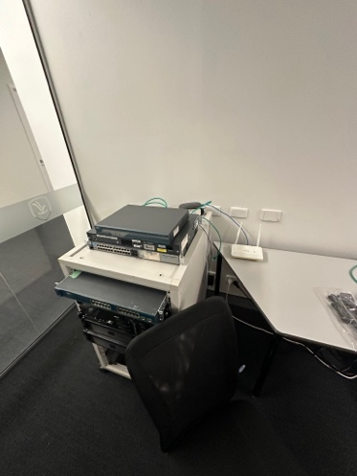  Comercial Router Cisco 1800 and SwitchCisco 3560  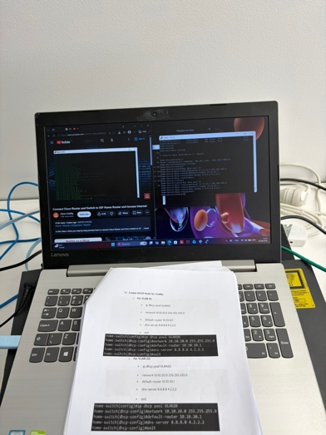  Laptop used to configure the Router and Switc  Network addressing  Router Configuration:  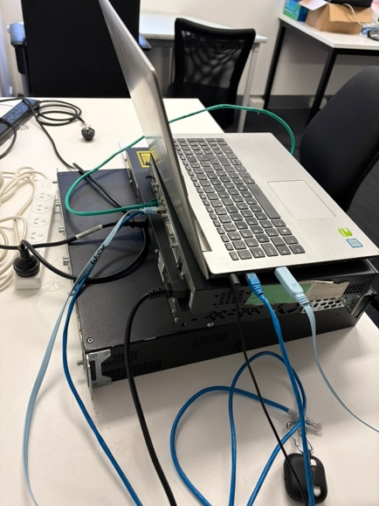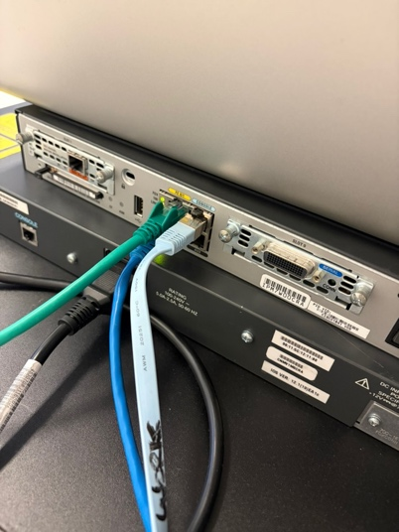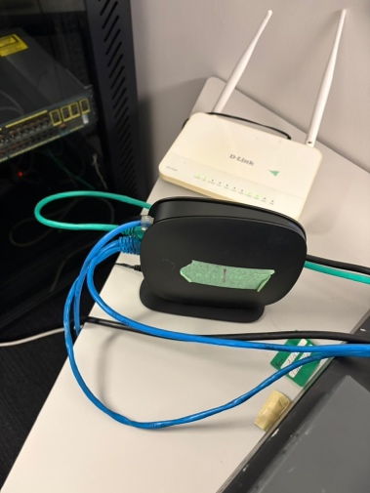  Laptop used to configurate Router/Switch by the Putty.  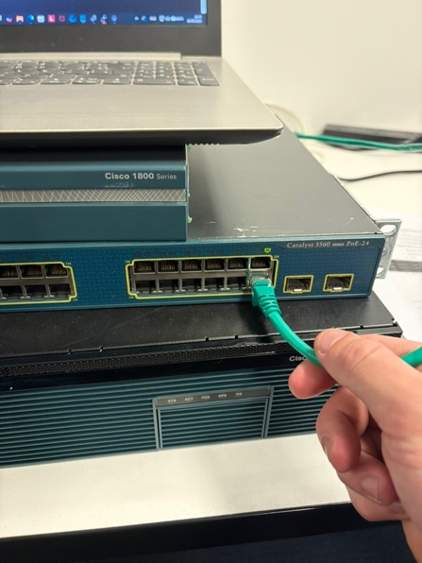  Switch FastEthernet 0/24 (connection between Router and Switch)  Conections:  - Home router to Cisco Router (blue cable Cat 6): Connected to LAN port of ISP Router to the FastEthernet 0/0 port on Cisco Router.  - Cisco Router to Switch (green cable Cat 6): Connnect to Cisco Router FastEthernet 0/1 to Cisco Switch FastEthernet 0/24  - Cisco Router to Laptop (console cable): Connected RJ45 end to the Console port on Cisco Router and USB end to a USB port on the laptop  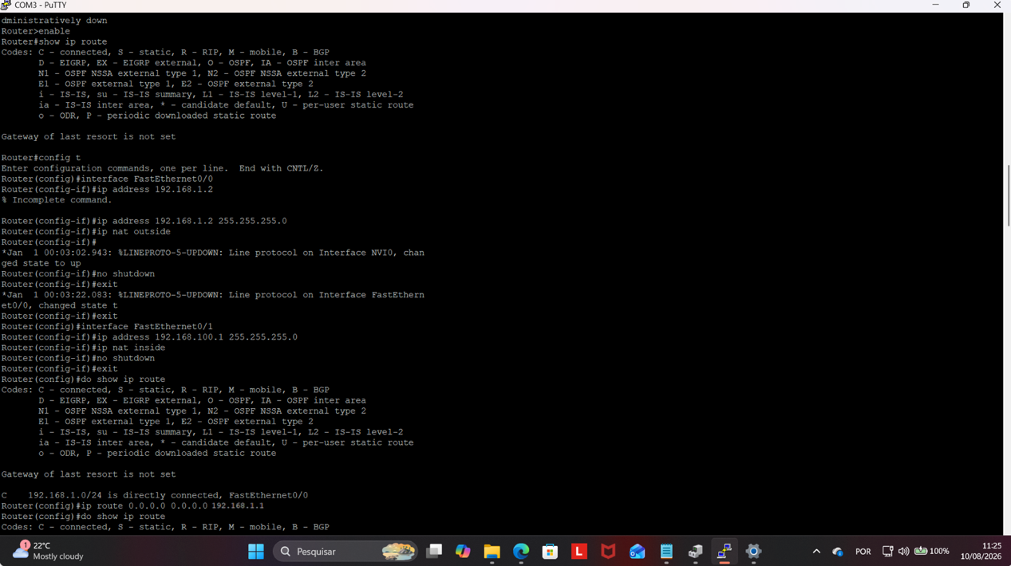  In this screenshot is possible to see the FastEthernet 0/0 and FastEthernet 0/1 configuration using the commands:  ▪ enable  ▪ config t  ▪ interface FastEthernet0/0  ▪ ip address 192.168.1.2 255.255.255.0  ▪ ip nat outside  ▪ no shutdown  ▪ exit  ▪ interface FastEthernet0/1  ▪ iip address 192.168.100.1 255.255.255.0  ▪ ip nat inside  ▪ no shutdown  ▪exit  And the Router to ISP:  ▪ip route 0.0.0.0 0.0.0.0 192.168.1.1  Between this last evidence and the next, I did the command ‘hostname Home-Router’ (is not in the screenshot) to change the hostname.  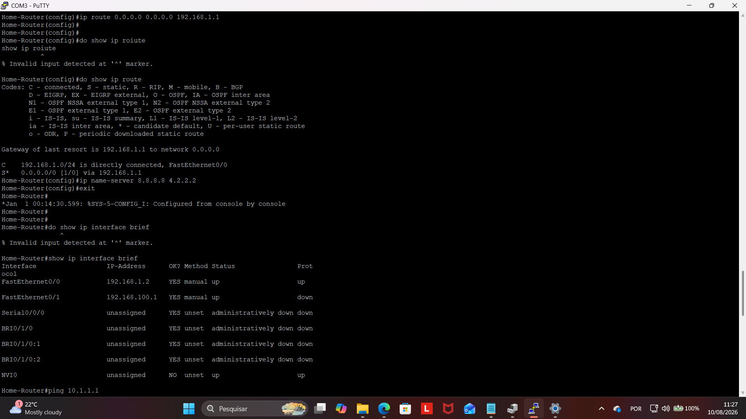  In this next evidence I configured the DNS Server by the command:  ▪ip name-server 8.8.8.8 4.2.2.2  Switch configuration:  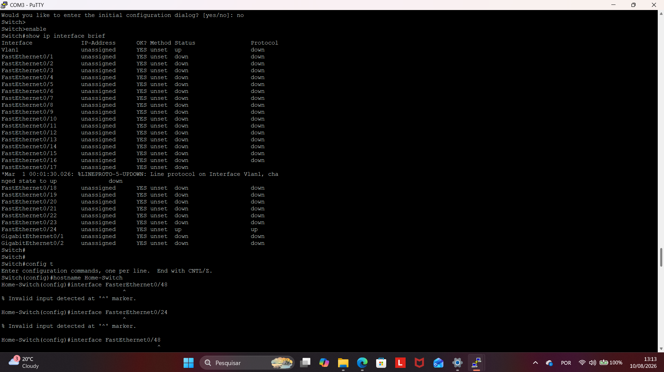  In this evidence is showing the command ‘hostname Home-Switch’ for the hostname change.  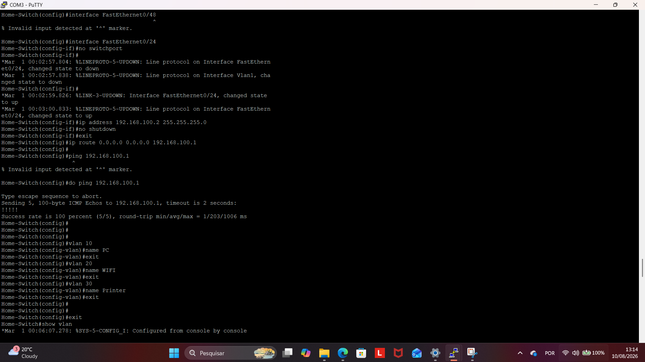  After change the hostname, I configured the FastEthernet 0/24 using the commands:  ▪config t  ▪no switchport (converts to a Layer 3 port)  ▪ ip address 192.168.100.2 255.255.255.0  ▪no shutdown  ▪exit  And the Static Route to Route configuration:  ▪ip route 0.0.0.0 0.0.0.0 192.168.100.1  Conectivity to Route test:  ▪do ping 192.168.100.1  And the VLANs creation:  vlan 10  ▪ name PC  ▪ exit  ▪ vlan 20  ▪ name Wi-Fi  ▪exit  ▪ vlan 30  ▪name Printer  ▪ exit  ▪Verify VLAN creation: do show vlan.  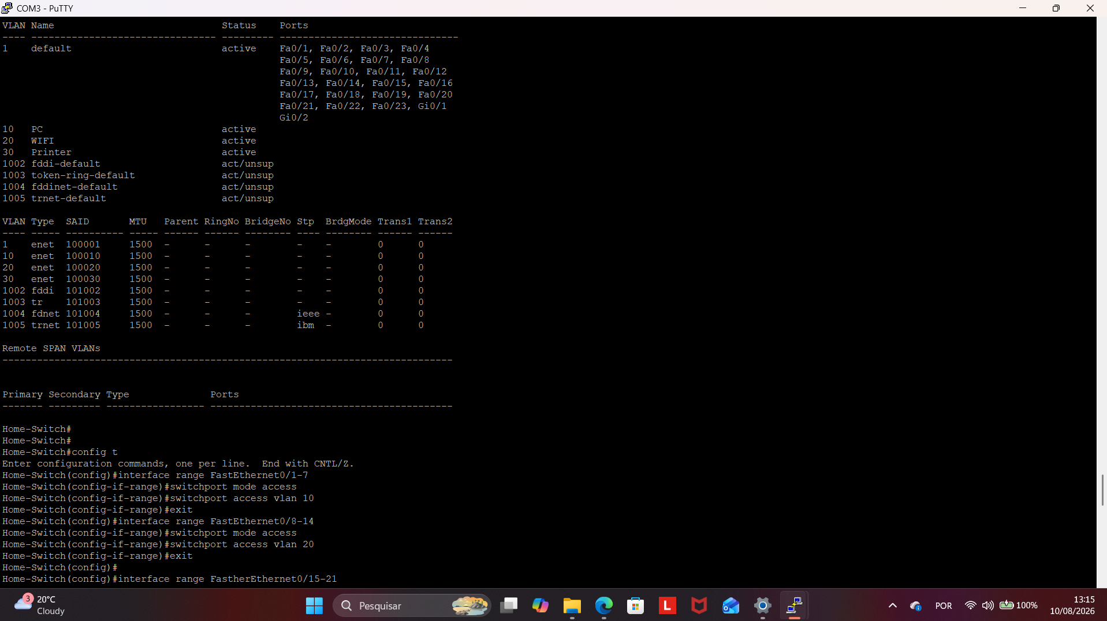  In this evidence is possible to see the VLANs created. After that was assign interfaces to each vlan:  -VLAN10 (Ports 1-7)  ▪interface range FastEthernet0/1 - 7  ▪switchport mode access  ▪switchport access vlan 10  ▪exit  -VLAN20 (Ports 8-14)  ▪interface range FastEthernet0/8 - 14  ▪switchport mode access  ▪switchport access vlan 20  ▪exit  -VLAN30 (Ports 15-21)  ▪interface range FastEthernet0/15 - 21  ▪switchport mode access  ▪switchport access vlan 30  ▪exit  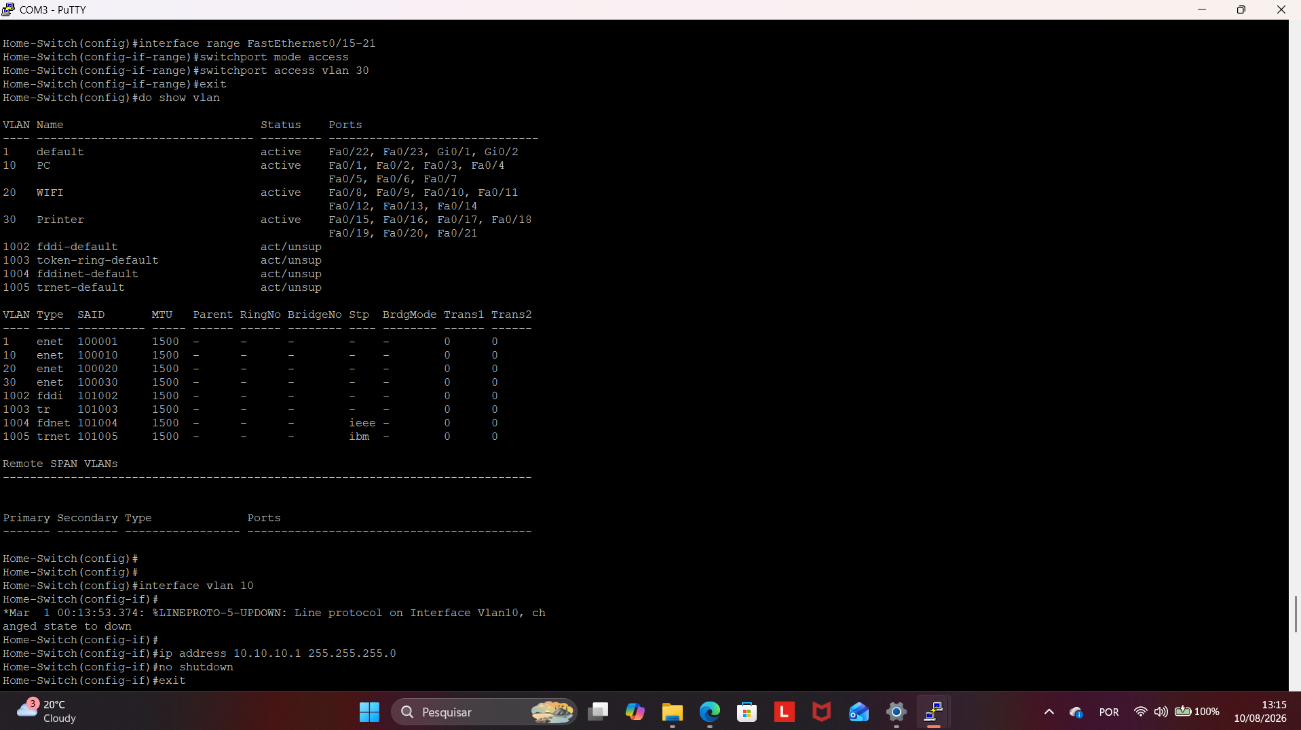  In this screenshot is possible see the end of the VLANS interface range creation and  All of the vlans active by the command ‘do show vlan’  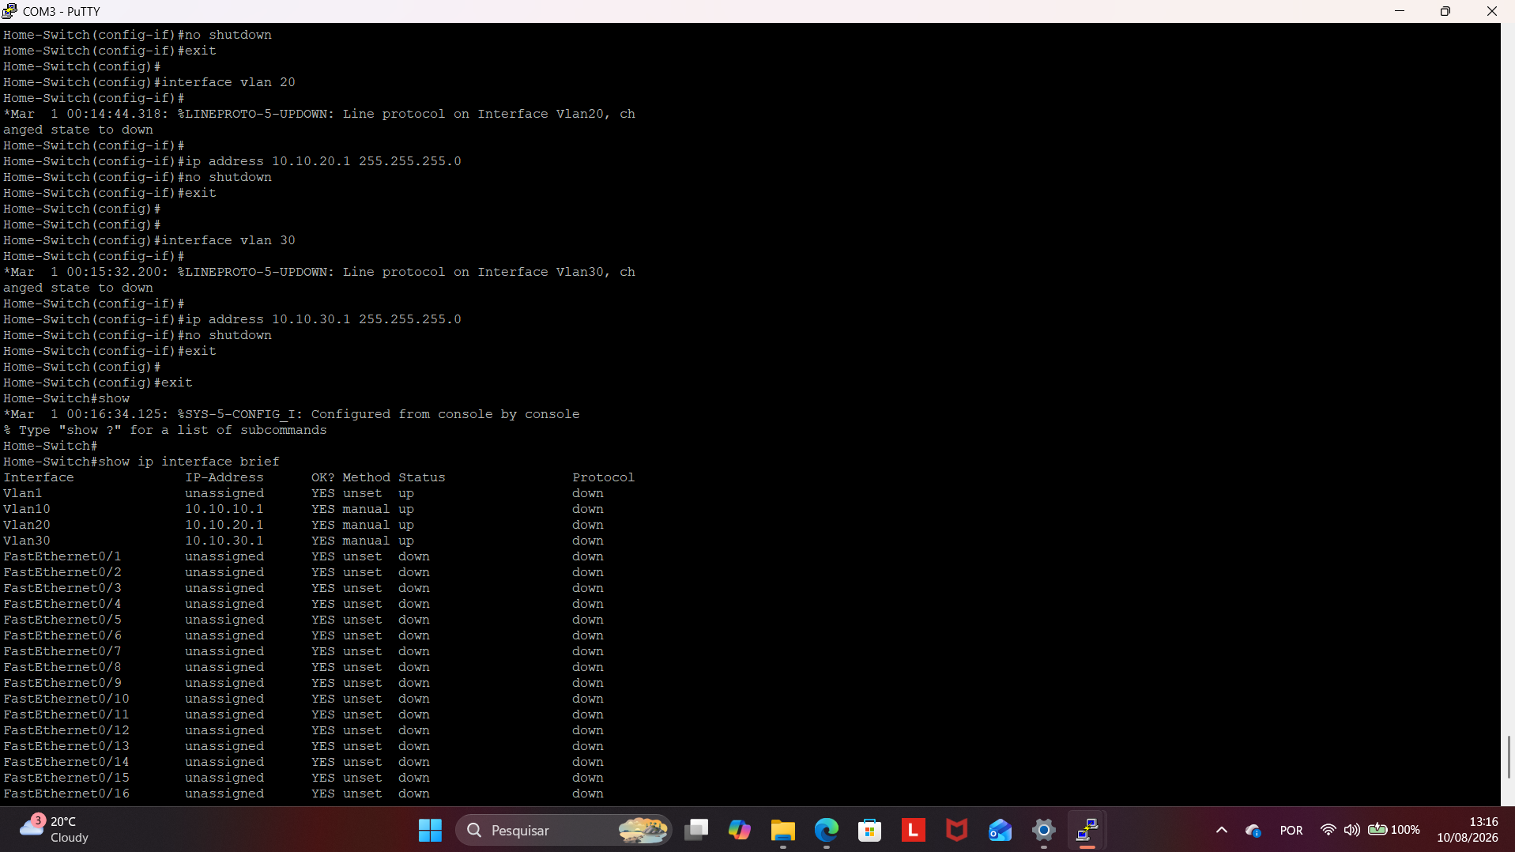  In this part was assigned IP Addresses to each VLAN interface by the commands:  ▪interface vlan 10  ▪ip address 10.10.10.1 255.255.255.0  ▪no shutdown  ▪exit  ▪interface vlan 20  ▪ip address 10.10.20.1 255.255.255.0  ▪no shutdown  ▪exit  ▪interface vlan 30  ▪ip address 10.10.30.1 255.255.255.0  ▪no shutdown  ▪exit  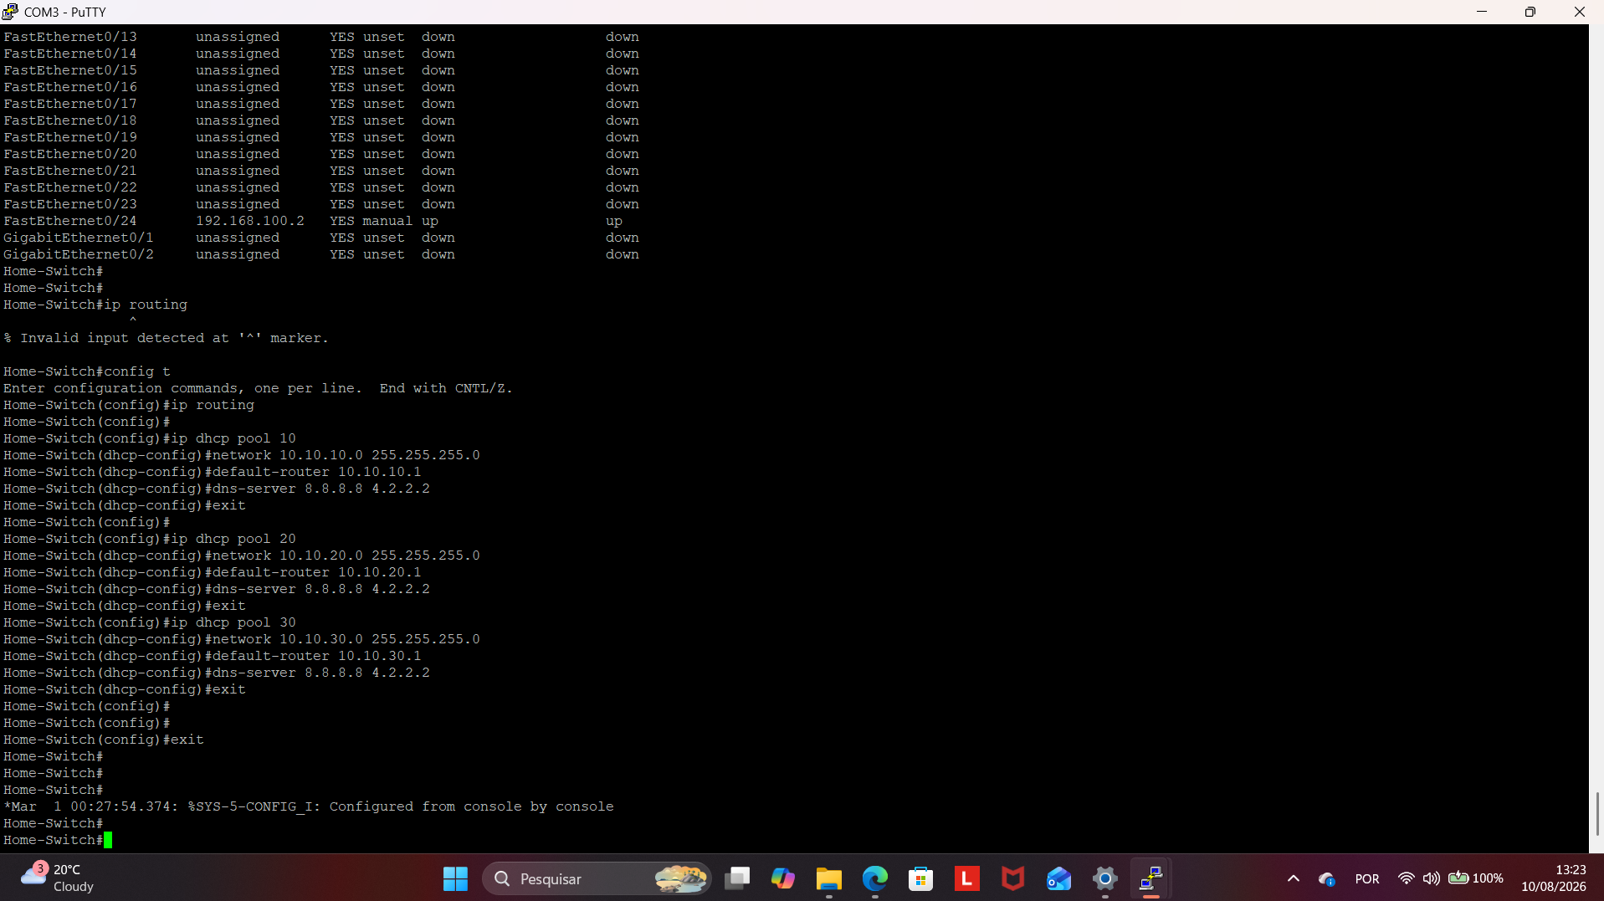  Here was used the command ‘ip-routing’ to allow communication between VLANs on the switch. Also was created DHCP pools for VLANs by the commands:  ▪ip dhcp pool 10  ▪network 10.10.10.0 255.255.255.0  ▪default-router 10.10.10.1  ▪dns-server 8.8.8.8 4.2.2.2  ▪exit  ▪ip dhcp pool 20  ▪network 10.10.20.0 255.255.255.0  ▪default-router 10.10.20.1  ▪dns-server 8.8.8.8 4.2.2.2  ▪exit  ▪ip dhcp pool 30  ▪network 10.10.30.0 255.255.255.0  ▪default-router 10.10.30  ▪dns-server 8.8.8.8 4.2.2.2  ▪exit  Connect again to the Cisco Router:  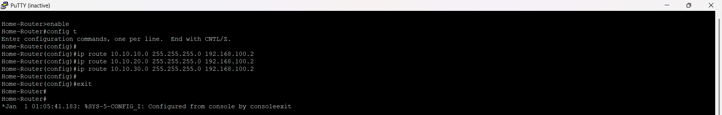  At this part, the console cable was connected to the Cisco Router, and this step enables VLAns to access the internet by the commands:  ▪enable  ▪config t  ▪ip route 10.10.10.0 255.255.255.0 192.168.100.2  ▪ip route 10.10.20.0 255.255.255.0 192.168.100.2  ▪ip route 10.10.30.0 255.255.255.0 192.168.100.2  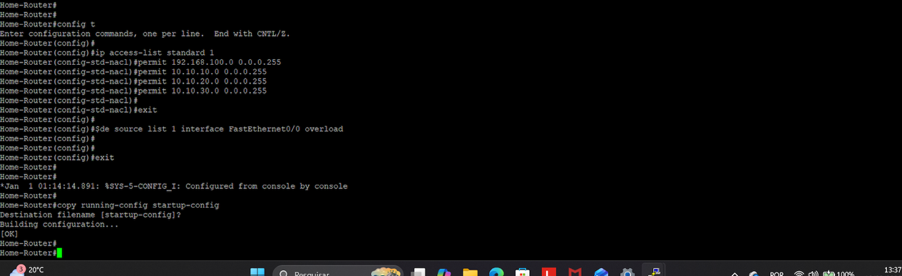  This part is the configuration to Access List and NAT  ▪ip access-list standard 1 (creates a standard access list named '1')  ▪permit 192.168.100.0 0.0.0.255 (permits the subnet connected to the routers LAN interface)  ▪permit 10.10.10.0 0.0.0.255  ▪permit 10.10.20.0 0.0.0.255  ▪permit 10.10.30.0 0.0.0.255  And Configure NAT overload (PAT):  ▪ip nat source list 1 interface FastEthernet0/0 overload  Testing Network:  Connect laptop to VLAN 10:  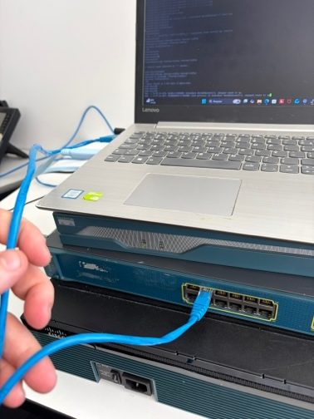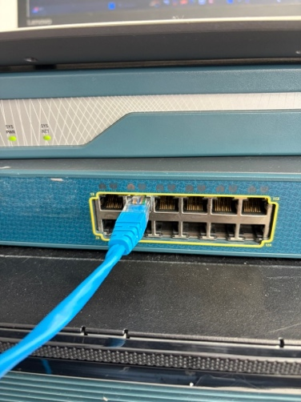  Laptop connected to Switch FastEthernet 0/3  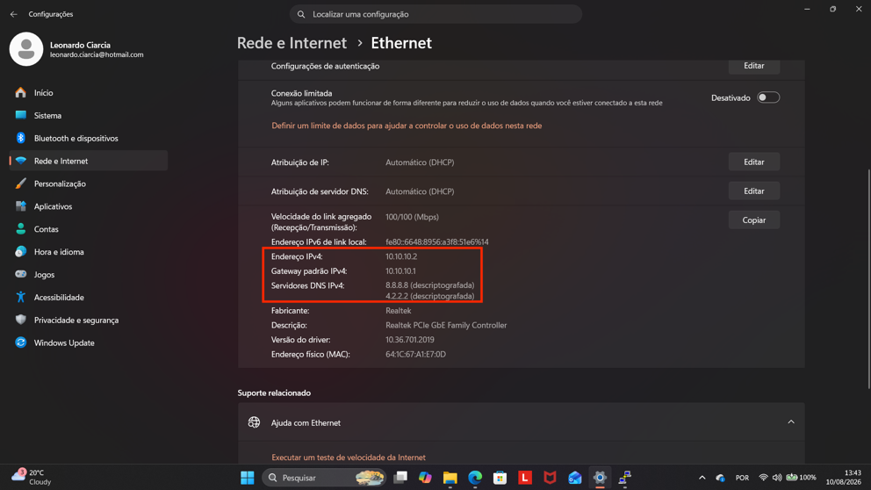  Laptop receiving IP address 10.10.10.2  Connect laptop to VLAN 20:  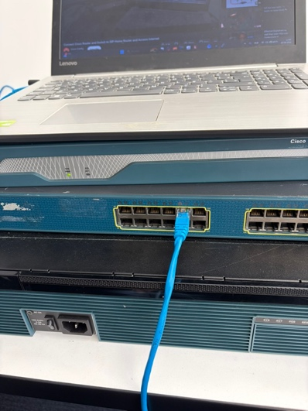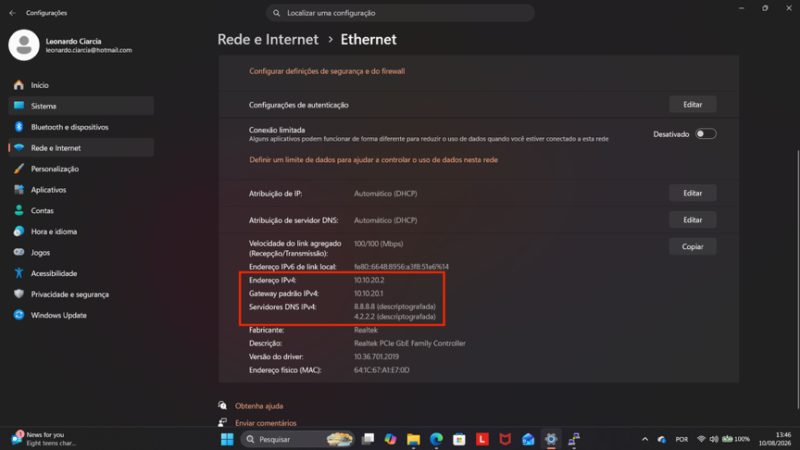  Laptop connected to Switch FastEthernet 0/9 and receiving IP Address 10.10.20.2  Connect laptop to VLAN 30:  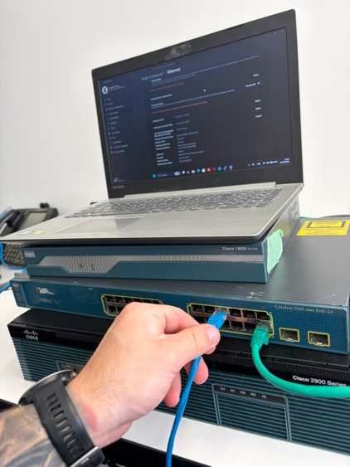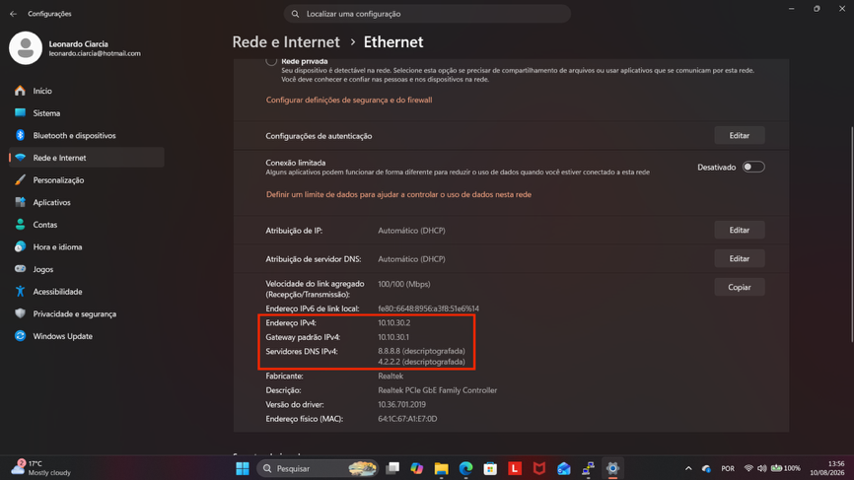  Laptop connected to Switch FastEthernet 0/17 and receiving IP Address 10.10.30.2  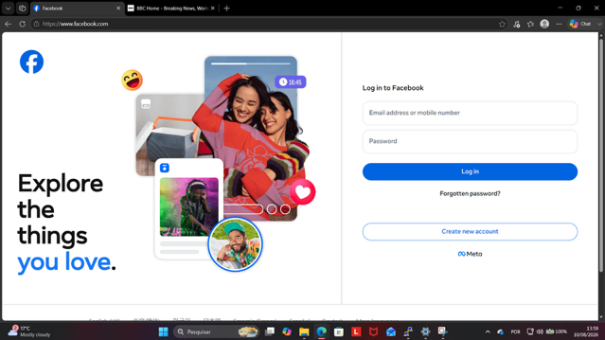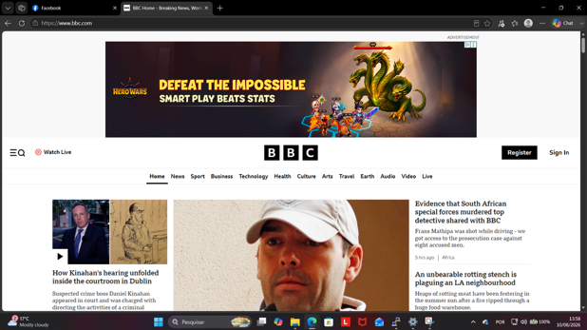  Testing internet by each VLAN searching facebook and bcc  - Demonstrate the planning, managing and implementing troubleshooting and monitoring strategies to ensure reliability and performance on advanced integrated internet protocol (IP) networks.  According to your enrolment date, you will need to demonstrate the following:  - Evaluating the impact of deregulation, competition, economic conditions, regulations and legislation on enterprise-specific policies and procedures and its subsequent incorporation into the planning process, as well as planning and designing for network additions and implementations to accommodate network growth and technologies in the industry.  Demonstration requirements  - Clearly explain to your assessor the findings and summary of your evaluation regarding the evaluation activities above.  - Your explanation must include details in your:  - Two (2) comprehensive reports where you have evaluated the economic and political influences on the networking industry in Australia and the impact of regulations and legislation on the networking industry.  - Two (2) summary reports where you have evaluated the impact of legislation on planning processes and accessibility to networks.  Required: You must include screenshots/ pictures (and/ or videos) of your demonstration’s activities.  Response:  i.Purpose of the evaluation  As part of the A-Plus Institute network upgrade, I evaluated how deregulation, market competition, economic conditions, legislation and regulatory requirements affect organisational policies and network planning. The findings were then incorporated into the final Network Option 2 and demonstrated through a smaller live laboratory prototype.  The production design accommodates five levels and future organisational growth. The practical prototype validates the essential technologies using an ISP CPE, Cisco router, Layer 3 switch, access point, wired devices, wireless devices, VLANs, DHCP, routing, NAT/PAT and monitoring commands.  ii.  Comprehensive Report 1: Economic and political influences  Deregulation and competition  The deregulation of the Australian telecommunications industry increased competition between carriers, internet service providers, equipment suppliers and managed service providers. Organisations such as A-Plus Institute can now compare providers based on price, bandwidth, service availability, support, cybersecurity features and service-level agreements.  Competition can reduce service costs and improve technology choices. However, selecting the cheapest provider may introduce risks such as inadequate support, limited redundancy, restrictive contracts or poor service restoration times. Therefore, the planning process included:  - comparison of supplier quotations and technical specifications;  - evaluation of total cost of ownership rather than purchase price alone;  - consideration of warranty, support and equipment lifecycle;  - selection of standards-based equipment to reduce vendor dependence;  - consideration of reliable internet connectivity and future WAN expansion;  - documentation of supplier responsibilities and service expectations.  The Australian Competition and Consumer Commission monitors competition and consumer interests in the telecommunications market. This made fair pricing, transparent contracts and service quality relevant considerations for the A-Plus procurement process.  Economic conditions  Inflation, currency movements, labour costs, equipment availability and supply-chain delays can affect the cost and schedule of a network project. Many enterprise networking products are imported, so changes in international prices and the Australian dollar may affect the final quotation.  These conditions were incorporated into the project by:  - providing a contingency allowance in the budget;  - comparing more than one supplier where possible;  - identifying acceptable alternative equipment;  - considering licensing, support, maintenance and replacement costs;  - implementing the network in planned stages;  - allowing sufficient time for equipment delivery and testing;  - reusing suitable existing infrastructure where it remained secure and functional.  Political and government influences  Government policy affects broadband availability, cybersecurity expectations, privacy obligations, workforce requirements and investment in digital education. A-Plus must maintain a network that supports reliable access to digital learning resources while protecting student, staff and organisational information.  The final design therefore prioritised security, scalability, monitoring, documentation and dependable access rather than focusing only on the initial installation cost.  Comprehensive Report 2: Regulations and legislation  The following requirements were considered during the planning and implementation process.  Relevant organisational policies were updated or considered, including:  - information security and privacy policy;  - acceptable-use policy;  - access-control and password policy;  - wireless security policy;  - backup and recovery policy;  - incident-response and data-breach policy;  - change-management policy;  - network monitoring and log-retention policy;  - procurement and asset-management policy;  - accessibility policy;  - WHS and safe-installation procedures.  Australian Privacy Principle 11 provides the central privacy-security requirement considered in this network design.  Summary Report 1: Impact of legislation on planning processes  Legislation influenced the network project from requirements gathering through implementation and ongoing maintenance.  During requirements gathering, the types of information handled by A-Plus were identified, including student, staff and administrative information. Privacy and security risks were then considered before selecting network equipment or designing VLANs.  During the design stage, separate VLANs were used for different user and device groups. This reduces unnecessary access between students, staff, servers, wireless devices and other resources. ACLs, secure administrative access, encrypted Wi-Fi and firewall controls were included to reduce unauthorised access.  During implementation, WHS controls were required for equipment movement, electrical connections, console configuration and network cabling. Changes were recorded, tested and approved before being introduced into the production environment.  The following planning decisions resulted from this evaluation:  - scalable VLAN and IP addressing structures;  - redundant core switching in the complete production design;  - additional wireless coverage for the expanded levels;  - capacity for future users and devices;  - secure Wi-Fi and administrative access;  - regular monitoring and performance testing;  - configuration backups and rollback procedures;  - scheduled IOS and firmware maintenance;  - documented incident and breach escalation;  - periodic legal and policy reviews.  Summary Report 2: Impact of legislation on accessibility  Network accessibility means that authorised students, staff and visitors can use required services safely and without unreasonable barriers. It does not mean that every user should have unrestricted access to all network resources.  The Disability Discrimination Act influenced the requirement to provide fair access to learning and communication systems. The network must support accessible applications, reliable wireless coverage and reasonable adjustments for users who may require assistive technologies.  Accessibility was incorporated into the A-Plus design through:  - improved Wi-Fi coverage across the planned levels;  - site-survey-based access point placement;  - support for laptops, tablets, phones and assistive devices;  - stable access to online learning systems;  - separation of user groups without preventing legitimate access;  - documented support procedures for users experiencing access difficulties;  - clear authentication and connection instructions;  - monitoring of weak coverage, congestion and connection failures.  Security and accessibility were balanced through role-based permissions, VLAN segmentation and controlled wireless access. These controls allow authorised users to reach the services they require while protecting administrative systems and personal information.  Incorporation into the live prototype  The laboratory prototype demonstrated how the planning findings were implemented technically:  - VLAN 10 separated wired workstations.  - VLAN 20 supported the access point and wireless devices.  - VLAN 30 separated printers or other client devices.  - DHCP automatically allocated addresses to authorised devices.  - Inter-VLAN routing provided controlled communication between networks.  - Static and default routes provided LAN-to-WAN connectivity.  - NAT/PAT protected private addressing and provided shared internet access.  - An ACL identified the internal networks permitted to use NAT.  - Configuration files were saved to support recovery.  - Monitoring commands confirmed interface status, VLAN membership, addressing, routes, DHCP allocation, NAT operation and connectivity.  - Ping, web access and traceroute tests verified reliability and identified where a connection failure could occur.  Figure 4 – Meeting Invitation  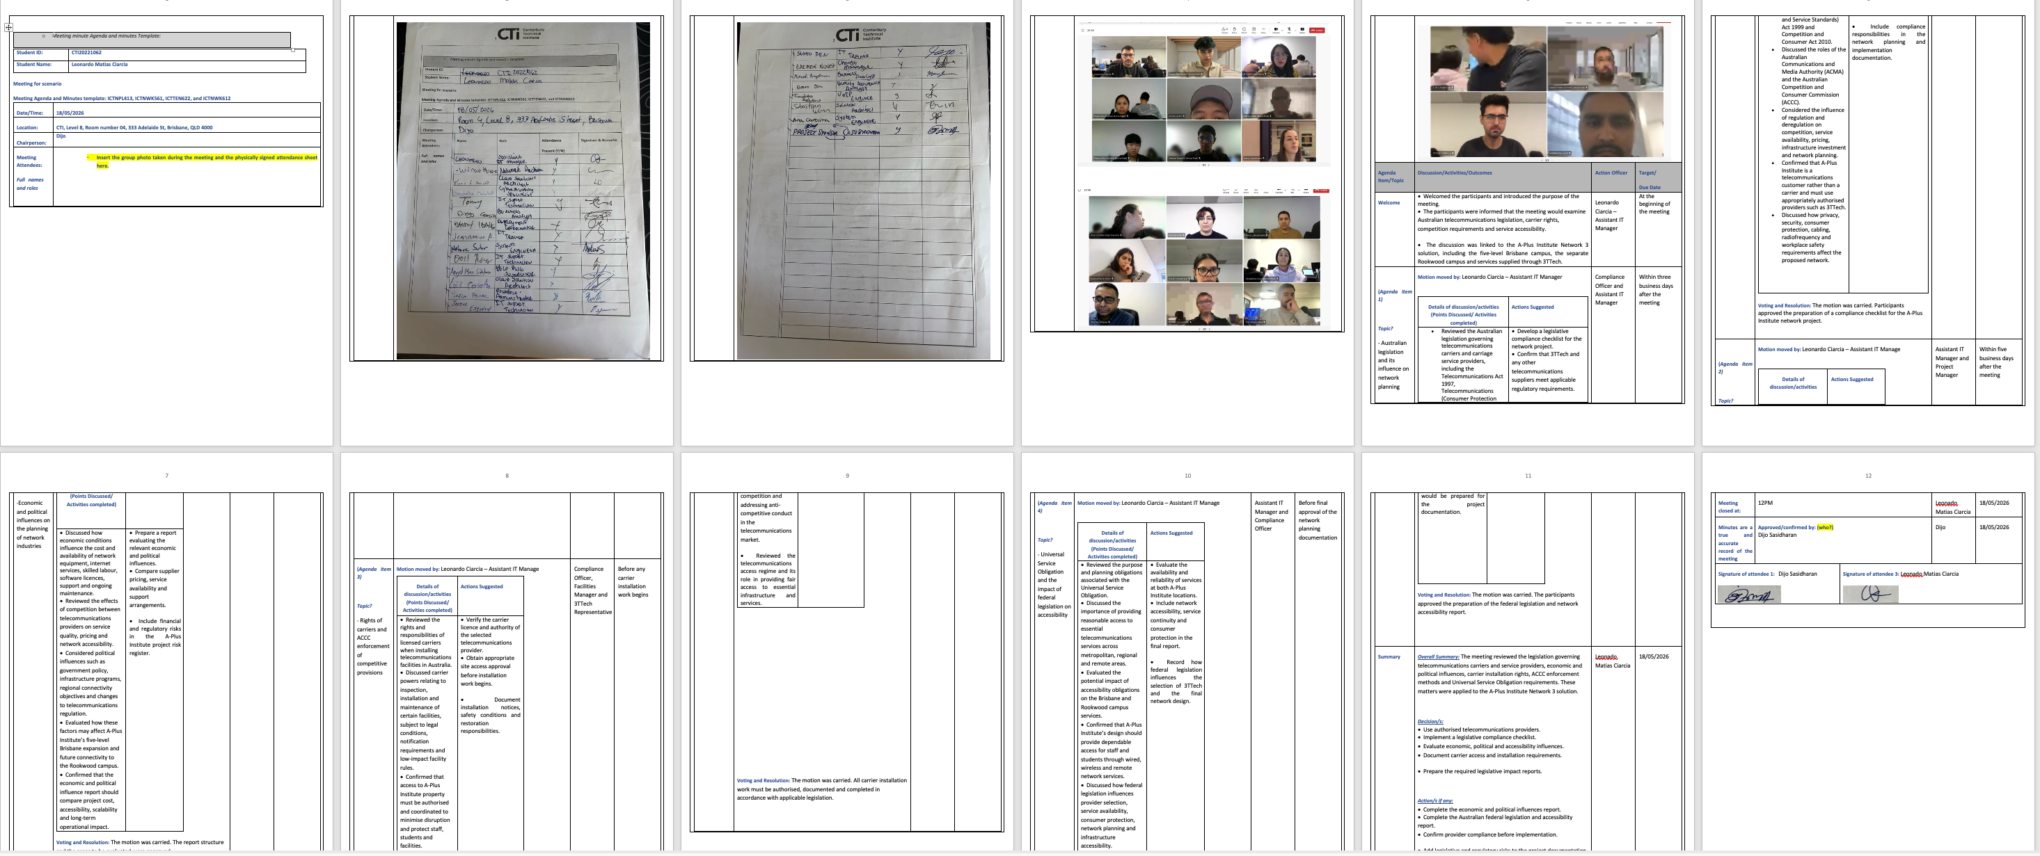  Figure 5 – Meeting agenda  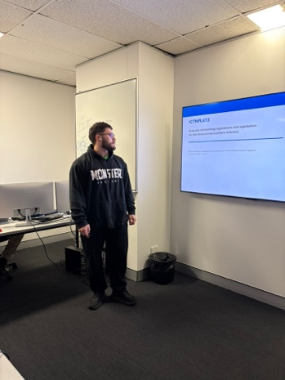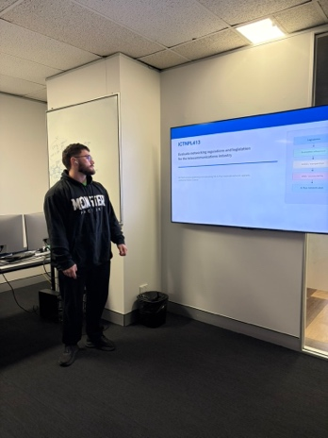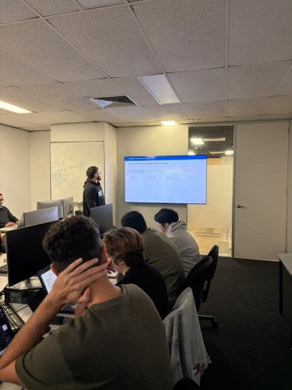  Figure 6 - Presentation  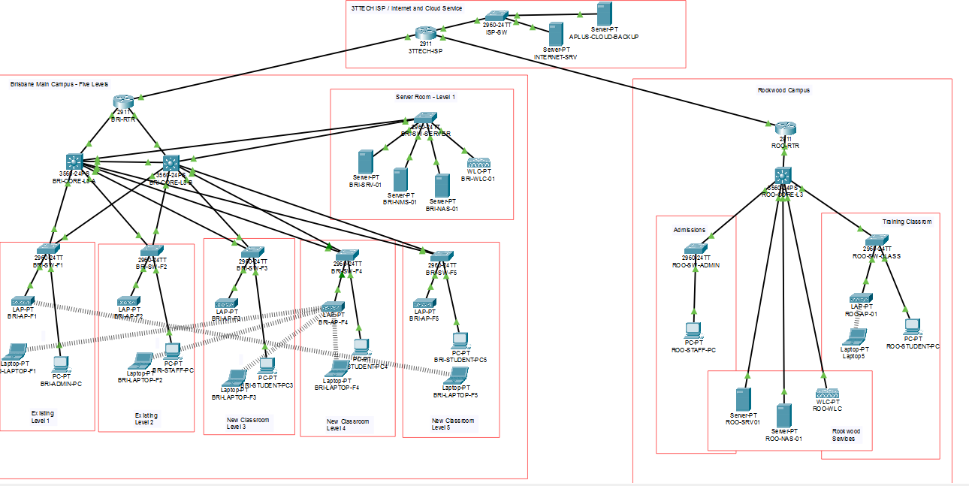  Figure 7 – Network Final Proposed  - Designing an enterprise wireless local area network (WLAN) and analyse existing network layouts and parameters.  Demonstration requirements  Clearly explain to your assessor and project team:  - your two design options for client’s enterprise wireless local area networks which you completed with the approved design and simulation tool (CISCO Packet Tracer)  - demonstrate the simulation of your design using the CISCO Packet Tracer  - Ensure you demonstrate and explain how you:  - assessed wireless network performance requirements for the client.  - measured and diagnosed wireless working environment.  - produced wireless models and network specifications that meet client requirements (you can use the live network you had set up in the ICT lab during this activity.  - produced wireless network designs and component lists.  - documented the design and obtain client approval.  - Explain using your proposed design, how you have met all the client requirements (current and future).  Required: You must include screenshots/ pictures (and/ or videos) of your demonstration’s activities.  Response:  i.  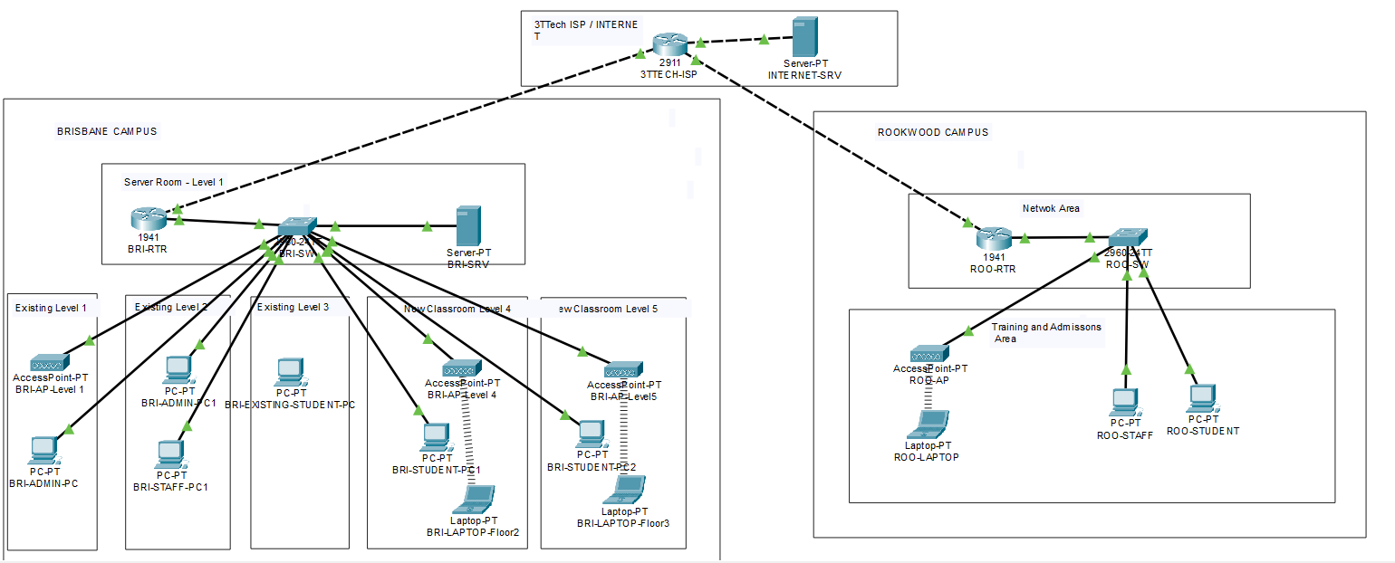Design Option 1 – Basic wireless network upgrade  Design Option 1 provided an initial improvement to the existing A-Plus network. It expanded wireless access and connected the required areas using a simpler topology. VLANs were used to separate different types of users and services, and access points were distributed across the required levels.  This option met the basic connectivity requirements and was less expensive to implement. However, it provided less redundancy, centralised control and capacity for long-term expansion. A failure of an important network device or uplink could affect a larger section of the network.  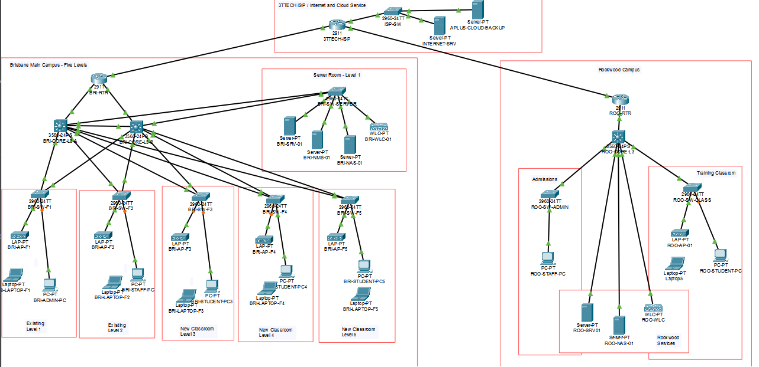  Design Option 2 – Final approved WLAN solution  Design Option 2 was selected as the final solution because it provided better performance, security, availability and scalability. The final design included the BRI-CORE-L3-A and BRI-CORE-L3-B multilayer core switches, access switches, wireless access points, central wireless management, VLAN segmentation, DHCP services, redundant paths and carrier connectivity through the ISP infrastructure.  The complete design supports five levels. Two access points per level were considered in the wireless planning to improve coverage and capacity. For clarity, the high-level Packet Tracer diagram may show one representative AP for a level; however, the detailed wireless plan and component list specify the required AP quantity.  The final solution separates wireless clients from network infrastructure. VLAN 40 and the 10.10.40.0/24 subnet are used for servers, the WLC and AP management. Corporate wireless clients use VLAN 60 and the 10.10.60.0/24 subnet, while guest wireless clients use VLAN 70 and the 10.10.70.0/24 subnet. This separation protects infrastructure and server resources while providing controlled wireless access.ii.  Cisco Packet Tracer was used to verify the logical design before physical implementation. The simulation demonstrated:  - correct physical and logical device connections;  - operational links between routers, core switches and access switches;  - VLAN creation and port assignment;  - wireless SSID configuration;  - wireless client association with an access point;  - DHCP address allocation;  - default-gateway configuration;  - inter-VLAN routing;  - connectivity between authorised networks;  - connectivity to the simulated ISP;  - redundant switching paths and loop prevention;  - expected packet flow through the network.  The design was first inspected in Real-Time mode to confirm that the required links were operational and displayed green status indicators. Simulation mode was then used to send ICMP packets and observe the path taken between the source device, access layer, core network and destination.  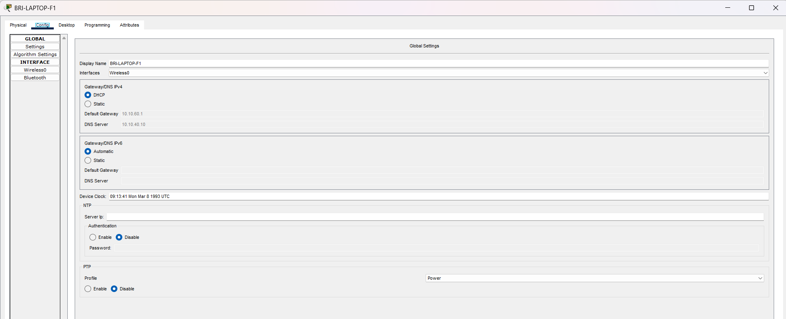  BRI-LAPTOP-F1 SSID and DHCP address.  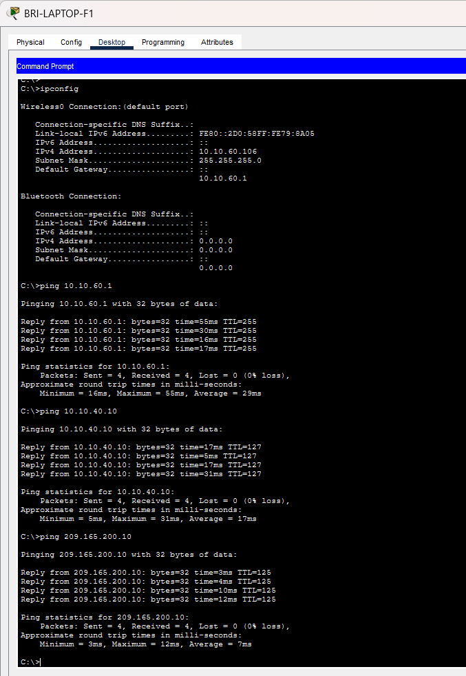  BRI-LAPTOP-F1 successful ping results to 10.10.40.10, 10.10.60.1 and 209.165.200.10.  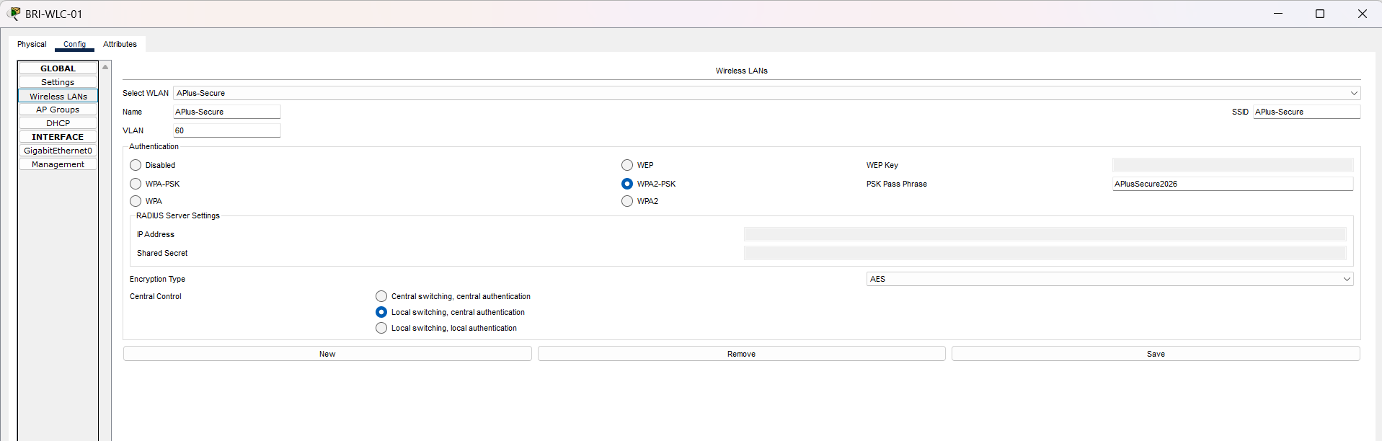  BRI-WLC-01 Wireless LANs showing Aplus-Secure -> VLAN60  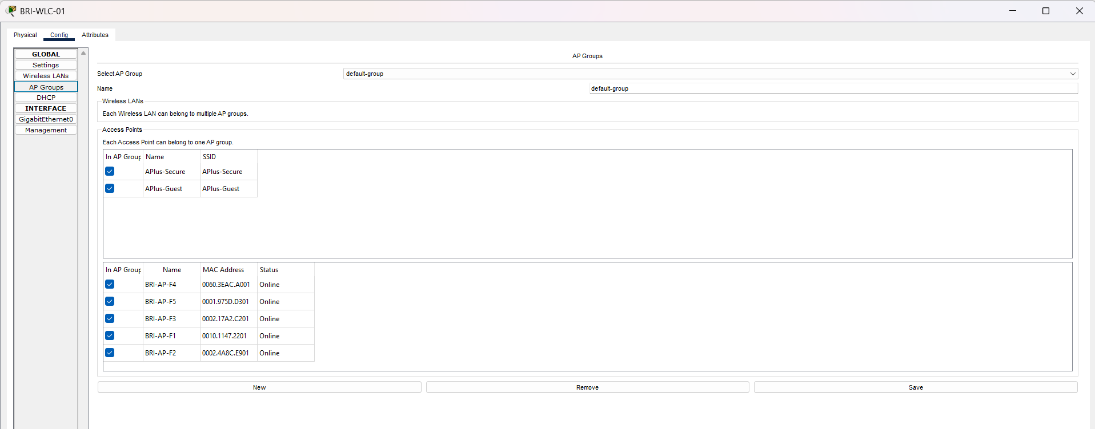  BRI-WLC-01 AP Groups showing five Aps online.  iii.  a) The wireless performance requirements were assessed by reviewing the client requirements, existing network layout, expected number of users, types of connected devices, building levels, application requirements and future organisational growth.  The following requirements were identified:  - continuous and reliable Wi-Fi coverage in the required teaching, administrative and common areas;  - sufficient capacity for students, trainers, administrative staff and visitors;  - support for laptops, tablets, smartphones and approved assistive devices;  - reliable access to online learning systems, cloud services, email and video conferencing;  - separation of wireless traffic from sensitive administrative and server networks;  - secure authentication and encryption;  - support for user movement between coverage areas;  - centralised wireless configuration and monitoring;  - capacity to add users, access points and new levels;  - minimisation of dead zones, interference and channel overlap;  - acceptable latency, packet loss and connection stability.  The final design was selected because it provided greater coverage, capacity, security, redundancy and scalability than the existing network and Design Option 1.  b) A wireless site-survey exercise was completed for two selected levels used as a representative testing area. NetSpot and TamoGraph were used to observe the wireless environment and record signal coverage, detected networks, channel usage, interference and possible weak-signal areas.  The survey process included:  - Reviewing the available floor layout.  - Identifying existing access point locations.  - Walking through the selected survey area with a wireless-enabled laptop.  - Recording signal strength at different positions.  - Identifying walls, furniture, electrical equipment and other obstacles.  - Checking for nearby networks using the same or overlapping channels.  - Identifying weak coverage and possible dead zones.  - Comparing the measurements with the proposed AP placement.  - Adjusting the proposed locations and channel plan where required.  - Recording the results for the final wireless design.  During the NetSpot survey, Level 8 displayed up to eight detected access point signals. These included other existing or nearby wireless networks that were outside the defined project model. For consistency with the project scope, two relevant access points per level were assessed and represented in the wireless plan. The other detected networks were considered when evaluating interference and channel utilisation but were not treated as A-Plus project access points.  Potential performance problems included signal attenuation through walls, overlapping channels, interference from surrounding networks, excessive distance from an AP and too many users connected to one access point.  The recommended responses included repositioning access points, using non-overlapping channels, balancing clients between access points, applying suitable transmit power, centralising AP management and completing a post-installation validation survey.  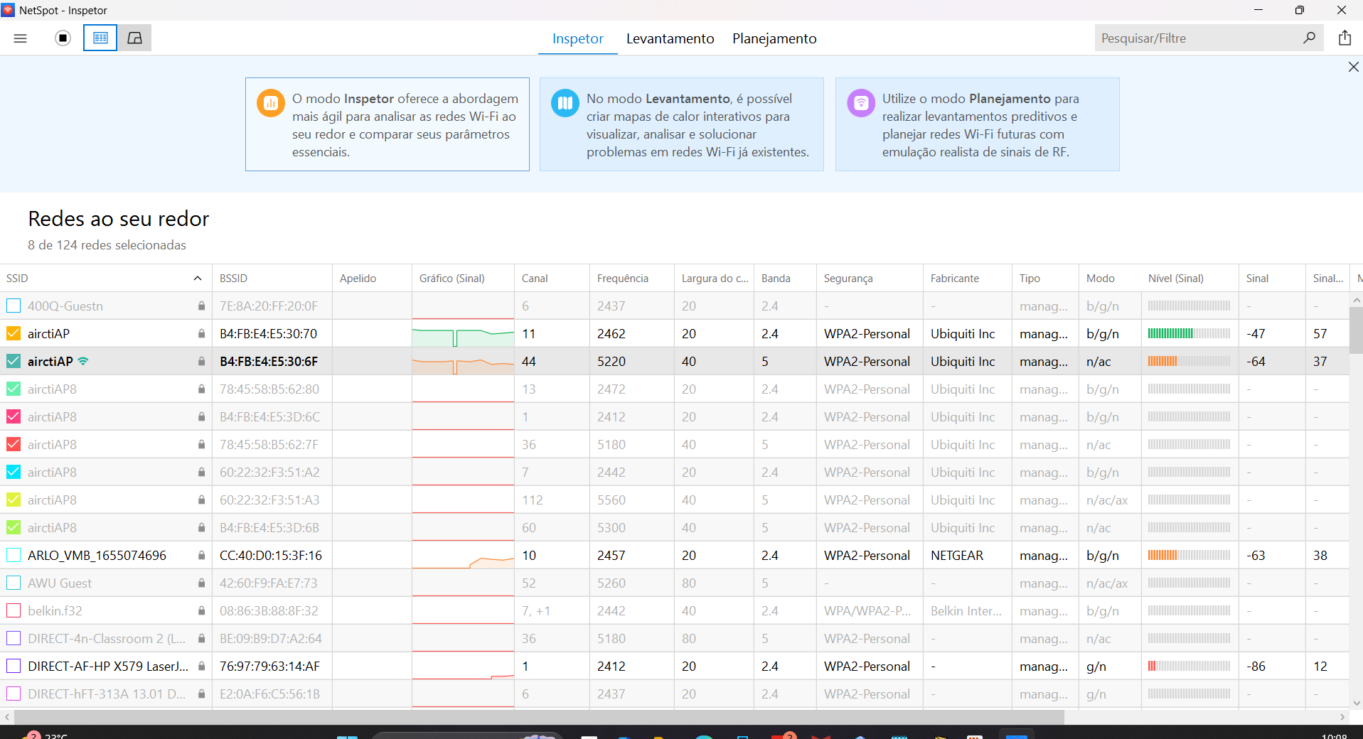  NetSpot – Level 1 | Show the radio evidence close to Classroom6  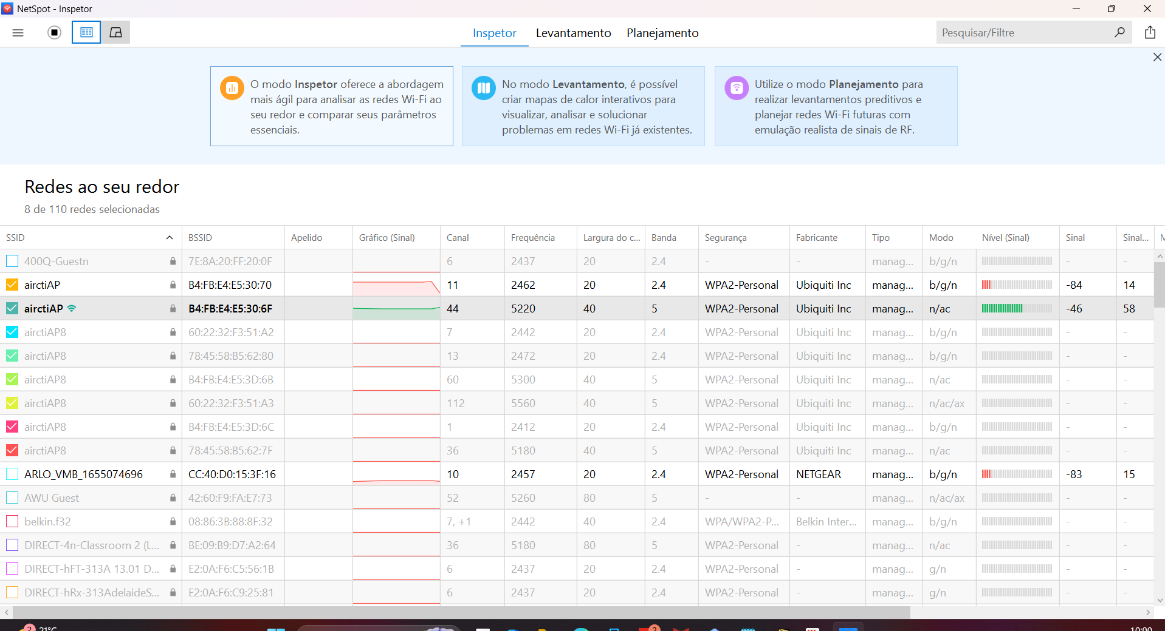  NetSpot – Level 1 | Show the radio evidence close to Commercial Kitchen  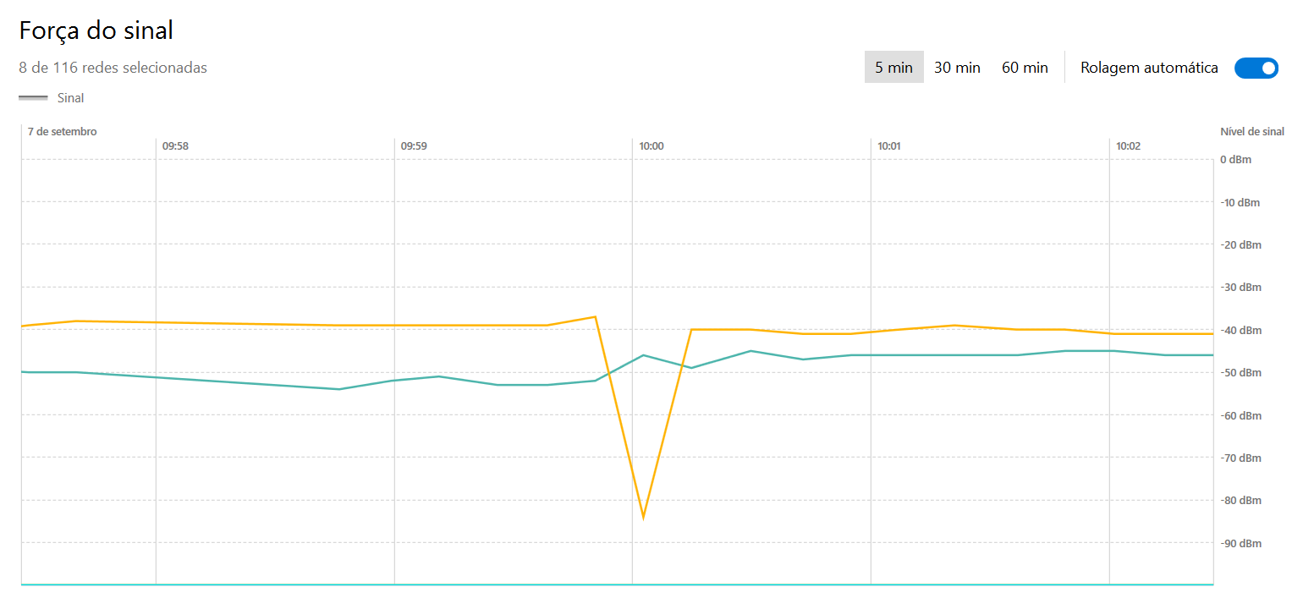  NetSpot – Level 1 | Show the radio evidence close to Commercial Kitchen (signal strength)  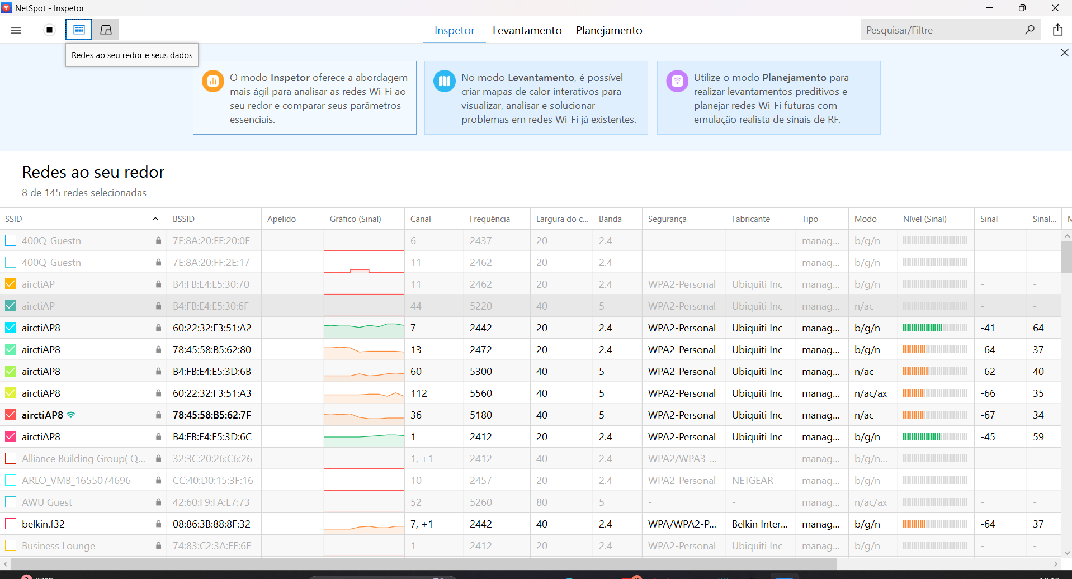  Netspot – Level 2 | Show the radio evidence In the Classroom5 (Gap between both AP)  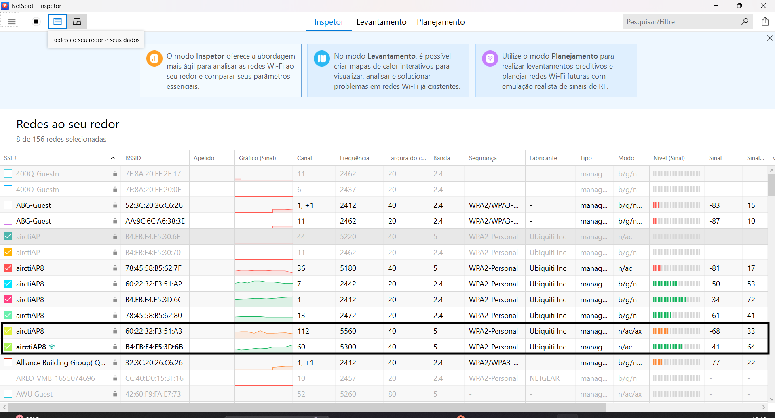  Netspot – Level 2 | Show the radio evidence close to Classroom1  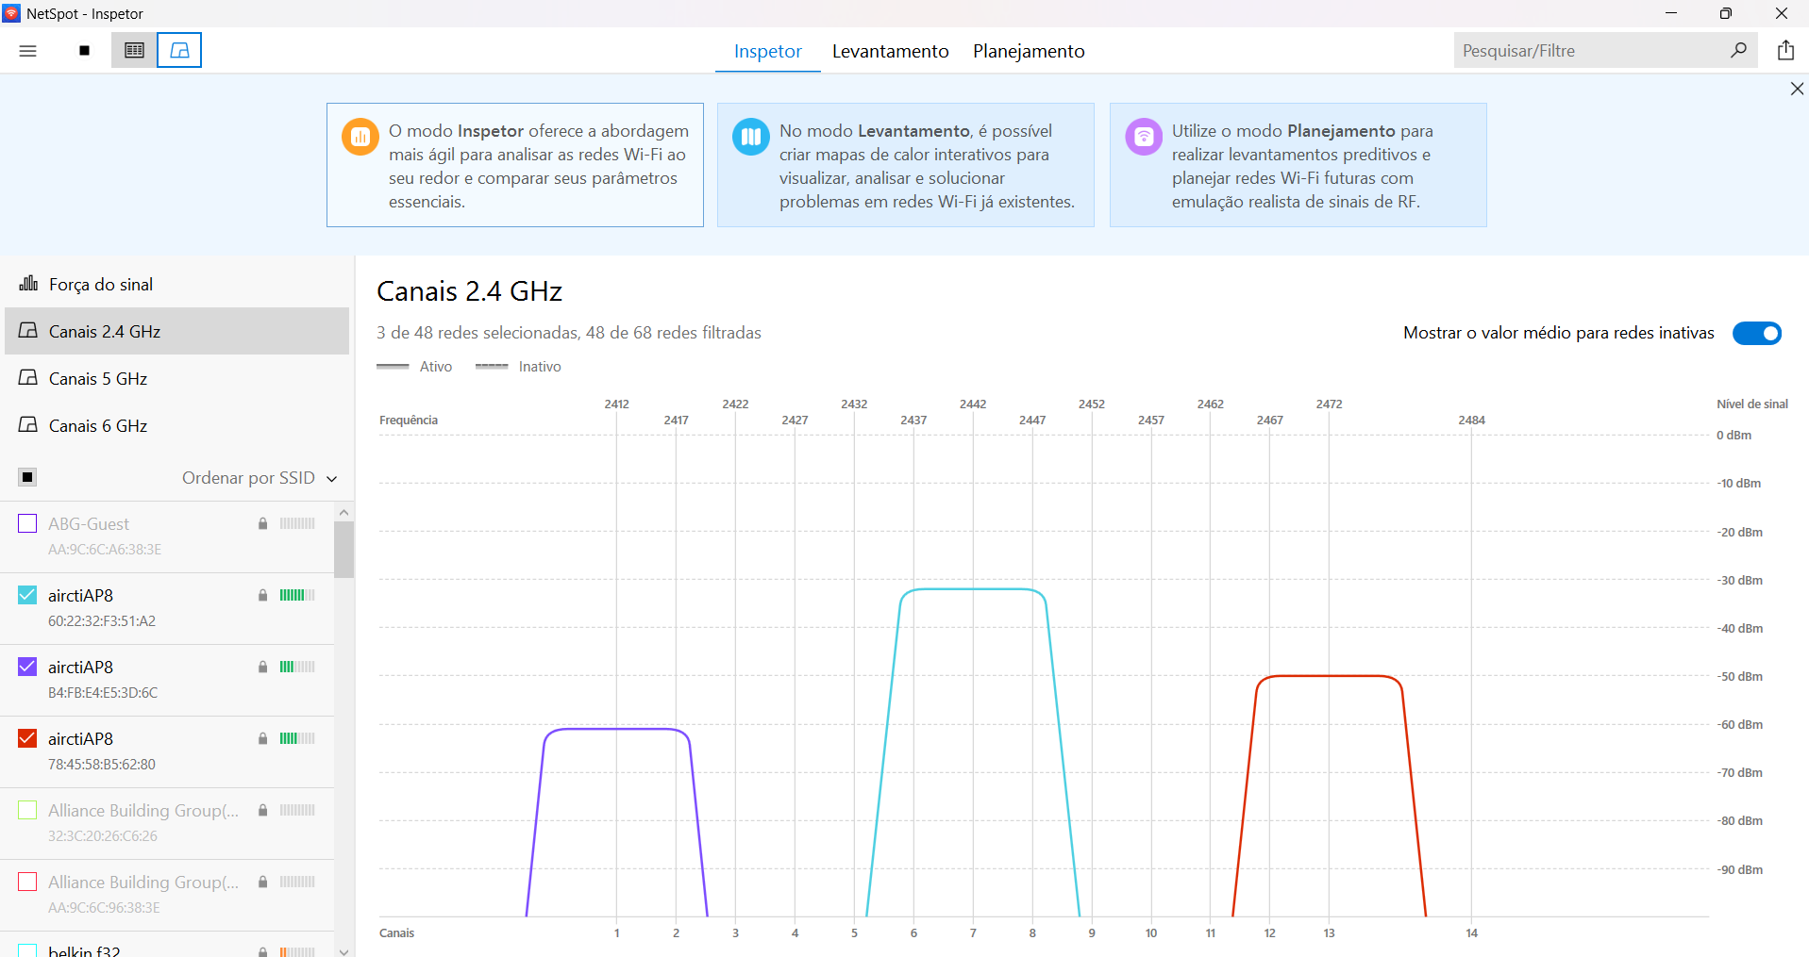  Netspot – Level 2 | Show the radio channel 2.4  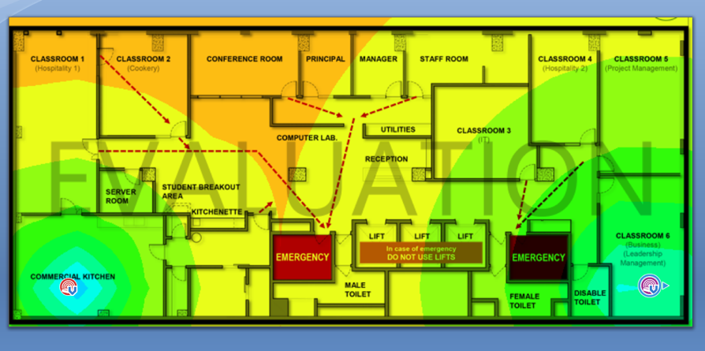  A-Plus Level 1 | TamoGraph Signal Level visualisation | Two AP placement markers are shown near the Commercial Kitchen and Classroom 6  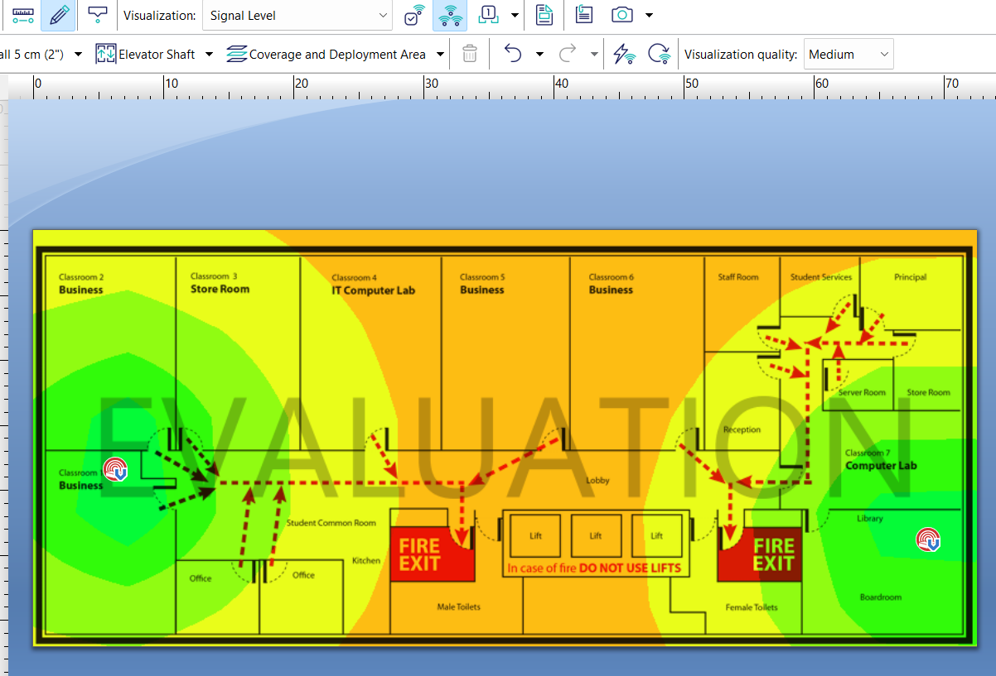  A-Plus Level 2| TamoGraph Signal Level visualisation | Two AP placement markers are shown on opposite sides of the level  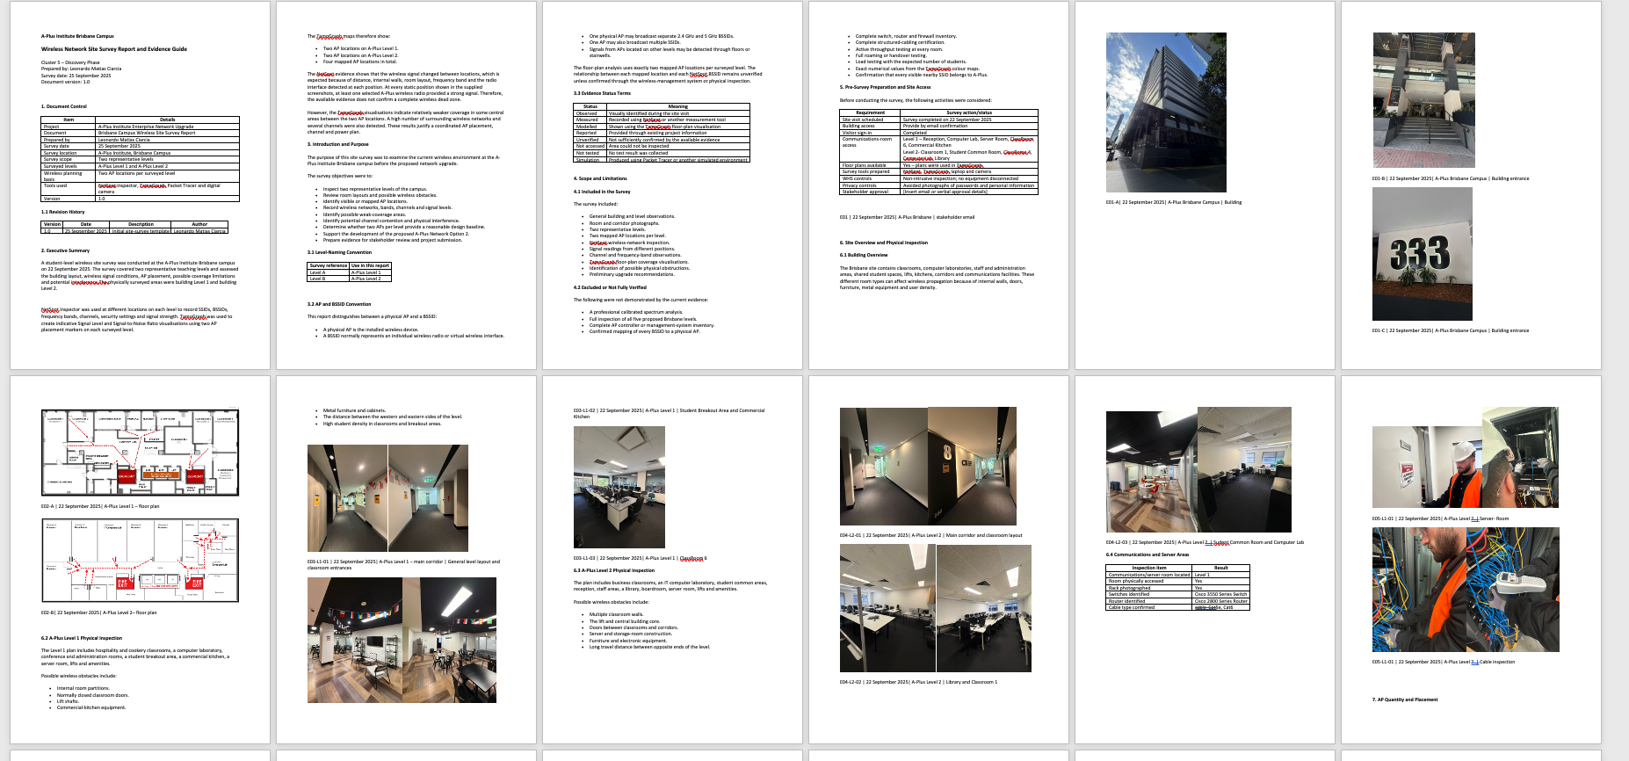  Site Survey document  c) The wireless solution was modelled using Cisco Packet Tracer. The model included routers, multilayer switches, access switches, a wireless LAN controller, access points, VLANs, DHCP services and wired and wireless end devices.  The main production WLAN specifications were:  A smaller physical prototype was also implemented in the ICT laboratory. It included an ISP CPE, Cisco router, Layer 3 switch, access point, wired client and wireless client. In that prototype, VLAN 20 and the 10.10.20.0/24 subnet represented the wireless service. This lab addressing was used to validate the technical function and does not replace the VLAN 40 addressing used in the complete A-Plus Network Option 2.  The live prototype demonstrated wireless association, DHCP allocation, LAN-to-WAN routing, NAT/PAT and internet access.  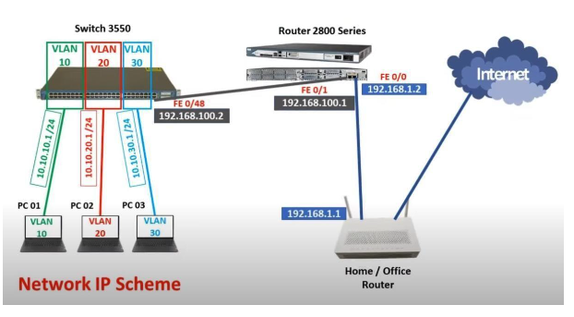  Live lab topology.  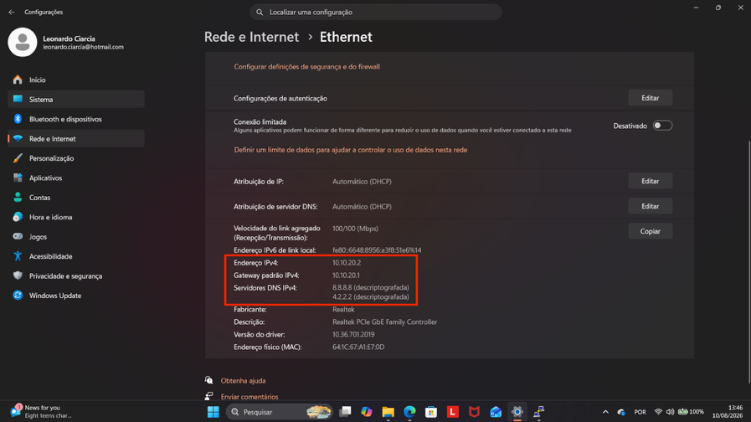  Wireless client receiving a 10.10.20.x address in the live prototype.  Successful wireless internet access or ping evidence from the live prototype.  d)  A component list was produced to support implementation of the final WLAN. It included:  The detailed component document records the manufacturer, model, quantity, technical specification, unit price and total price for the selected equipment.  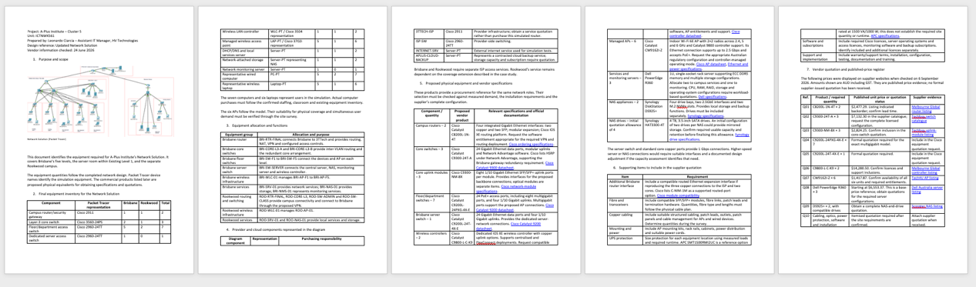  Components List and product specifications.  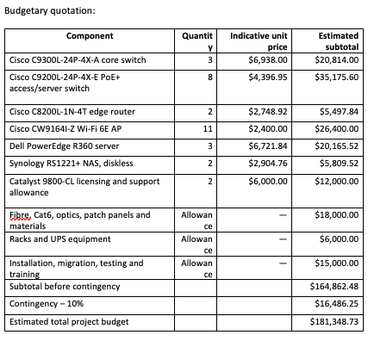  quotation table.  e)  The wireless design was documented through:  - client requirements summary;  - current network diagram;  - Network Option 1 diagram;  - final Network Option 2 diagram;  - site-survey report;  - IP addressing schema;  - VLAN information;  - component list and product specifications;  - supplier quotation;  - implementation plan;  - test and monitoring plans;  - security and risk controls;  - technical report;  - final network documentation;  - project sign-off form.  The two options were presented to the client or authorised stakeholder. Design Option 2 was recommended because it offered better redundancy, wireless coverage, security, central management and capacity for future growth.  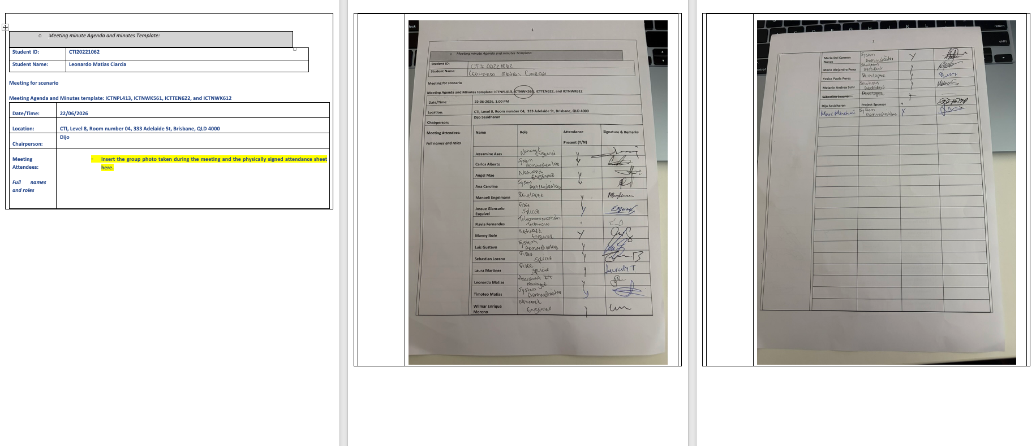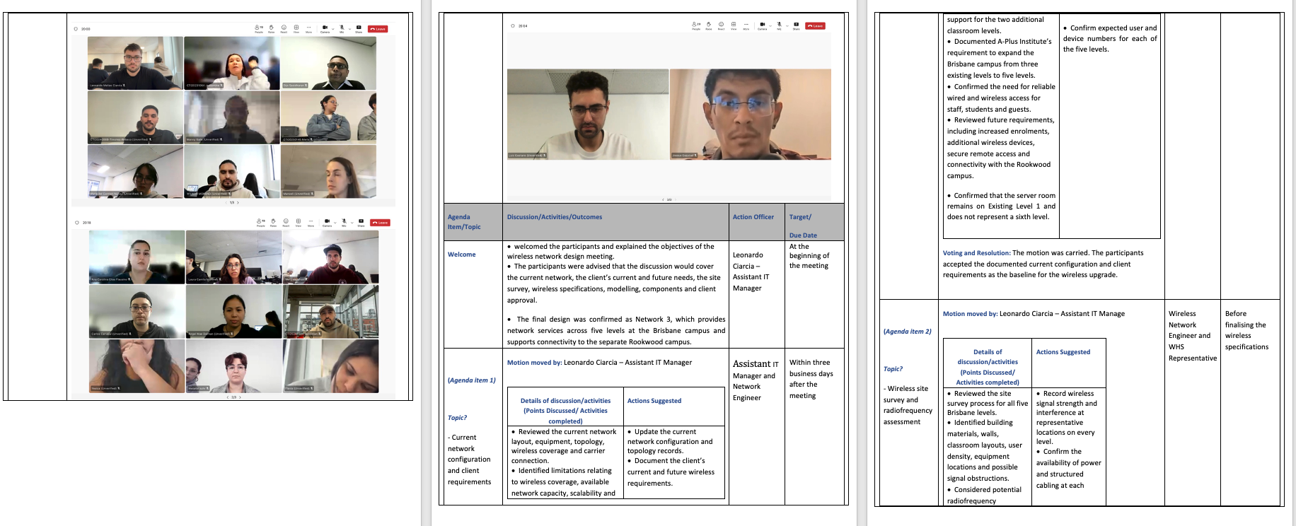  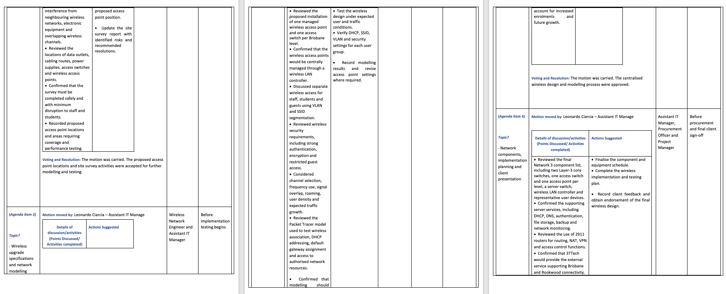  Meeting agenda and minutes  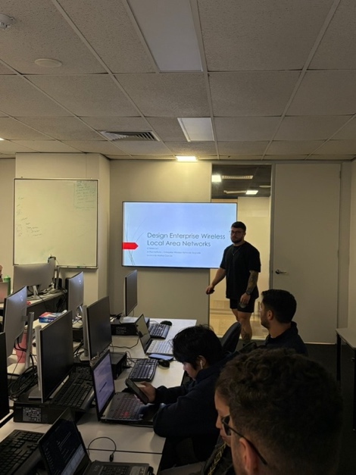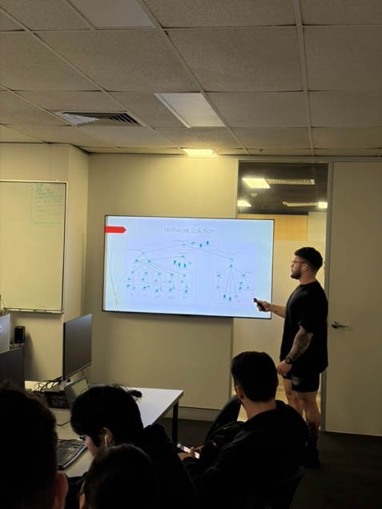  Presentation to stakeholder  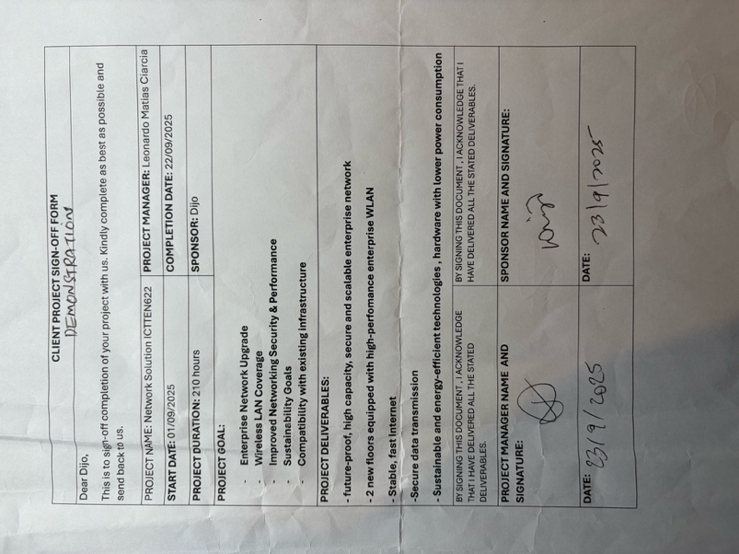  iv.  Conclusion  The evaluation showed that Network Option 2 best meets the current and future requirements of A-Plus Institute. The design provides secure wireless access, network segmentation, centralised management, reliable coverage, redundant core connectivity and capacity for expansion.  Cisco Packet Tracer testing confirmed the logical operation of the design, while NetSpot and TamoGraph supported the evaluation of the wireless environment. The smaller live laboratory prototype demonstrated that the main services—including wireless access, DHCP, routing, NAT and internet connectivity—could operate successfully before full implementation.  - Compiling and evaluating business specifications from a client and produce a set of architecture design solutions to cater for present and future forecast demands and integrate converging and emerging technologies of ICT networks.  Tips: This is based on the previous weekly activities completed.  Demonstration requirements  Clearly explain to your assessor and project team:  - Your two (2) information communications technology (ICT) network architecture designs for your client.  - Ensure you demonstrate and explain how you:  - adapted technologies to specified technical solutions.  - used site design software and hardware.  - evaluated client specifications against accepted industry practices.  - produced technical designs from business specifications.  - analysed feedback from client and adjust proposal.  - applied design concepts to business solutions.  - produced technical reports.  - made recommendations and offer optimum design solutions for the cluster 5.  Required: You must include screenshots/ pictures (and/ or videos) of your demonstration’s activities.  Response:  i.  Two network architecture options were developed for A-Plus Institute. Both designs support the Brisbane and Rookwood campuses, wireless connectivity, network segmentation and access to organisational resources. However, they provide different levels of reliability, scalability and centralised management.  Network Option 1 – Basic alternative design  Network Option 1 was designed as a lower-cost improvement to the existing network. It used a Cisco 2911 router and Cisco 2960 main switch at each campus. Inter-VLAN communication was provided through a router-on-a-stick arrangement, where one trunk connection carried traffic for multiple VLANs between the router and switch.  Wireless connectivity was provided by autonomous access points that required individual configuration. Core services such as DHCP, DNS and file storage were primarily located at the Brisbane campus. Brisbane and Rookwood were connected through an encrypted site-to-site VPN using the 3TTech service.  Advantages:  - lower initial implementation cost;  - simpler equipment requirements;  - VLAN separation for different user groups;  - secure communication between campuses;  - suitable for a smaller environment.  Limitations:  - dependence on a single router, switch and trunk connection;  - limited redundancy;  - more manual access point administration;  - reduced scalability;  - greater impact if the central Brisbane services become unavailable;  - less suitable for the planned five-level Brisbane environment.  Network Option 2 – Final recommended design  Network Option 2 was developed as the final enterprise solution. It uses a hierarchical and redundant architecture designed for improved performance, availability, security and future expansion.  At Brisbane, the design includes:  - two Layer 3 core switches: BRI-CORE-L3-A and BRI-CORE-L3-B;  - five PoE access switches: BRI-SW-F1 to BRI-SW-F5;  - one access-switching area for each of the five levels;  - a dedicated server switch;  - centrally managed wireless access points;  - two planned access points per Brisbane level;  - wireless LAN controller;  - local server, NAS and network monitoring services;  - redundant core and access-layer uplinks;  - connection to the 3TTech service.  At Rookwood, the design includes:  - ROO-CORE-L3;  - managed access switching;  - local server and NAS services;  - managed wireless connectivity;  - connection to Brisbane through the 3TTech site-to-site IPsec VPN.  The detailed component list includes three Layer 3 core switches, seven PoE access switches, one server switch, two wireless LAN controllers, eleven physical access points, three servers, two NAS units, Cat6 cabling, OM4 fibre uplinks and supporting network equipment.  The Packet Tracer diagram uses one representative AP icon per Brisbane level to keep the topology readable. The detailed design and component list specify ten physical Brisbane APs, representing two APs per level. One additional AP is allocated to Rookwood.  ii.  a)  The technologies were adapted to the size, physical layout, security requirements and available budget of A-Plus Institute.  In Network Option 1, router-on-a-stick technology was used because it provided VLAN routing with fewer devices and a lower initial cost. Autonomous APs were suitable for a smaller installation but required separate configuration.  For Network Option 2, routing was moved to the Layer 3 core switches. This improved performance by allowing inter-VLAN traffic to be routed at the core instead of passing through a single router trunk. Redundant core switches and uplinks were introduced to reduce single points of failure.  Wireless technology was adapted by replacing individually managed APs with controller-managed APs. This allows consistent SSID, security, channel and transmit-power settings. It also simplifies monitoring and future expansion.  The design used separate functional VLANs:  Rookwood uses the corresponding VLANs 110, 120, 130, 140, 160 and 170 with 10.20.x.0/24 addressing. This maintains a consistent structure while preventing addressing conflicts between campuses.  The physical laboratory prototype used the available Cisco router, Layer 3 switch and access point. In the smaller lab model, VLAN 20 represented Wi-Fi. This was a functional prototype used to validate DHCP, routing, NAT and wireless connectivity.  b)  The following software was used:  The site-survey and implementation hardware included:  - wireless-enabled laptop or tablet;  - smartphone or camera for photographic evidence;  - physical Cisco router and Layer 3 switch;  - wireless access point;  - wired workstation and wireless/mobile client;  - console cable;  - Cat6 Ethernet cables;  - cable tester or network scanner;  - floor plans;  - label maker;  - flashlight;  - relevant PPE.  NetSpot detected several nearby access point signals, including up to eight signals on Level 8. These included other existing or neighbouring networks. Only the two APs relevant to each level were used in the detailed A-Plus model, while the other detected signals were considered when assessing channel congestion and interference.  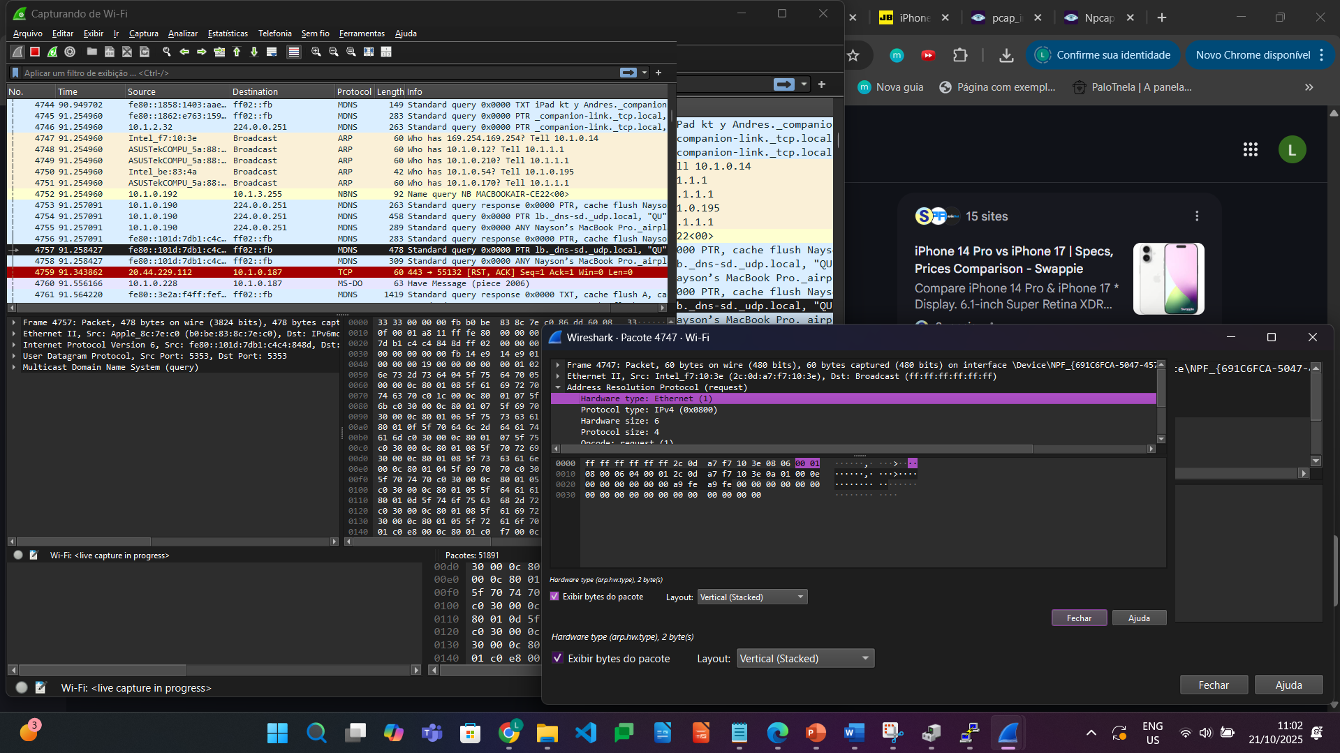  WireShark evidences  Physical lab equipment and connections:  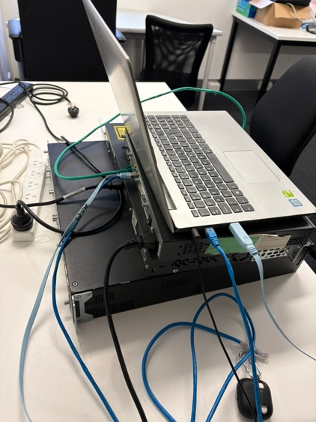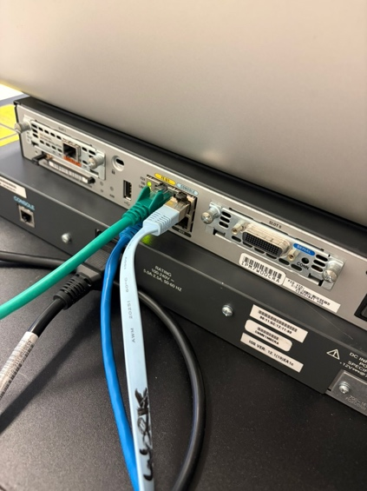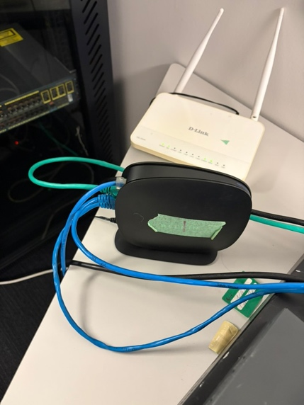  Laptop used to configurate Router/Switch by the Putty.  Switch FastEthernet 0/24 (connection between Router and Switch)  Laptop connected to Switch FastEthernet 0/3  Laptop connected to Switch FastEthernet 0/9 and receiving IP Address 10.10.20.2  Laptop connected to Switch FastEthernet 0/17 and receiving IP Address 10.10.30.2  c)  The client specifications were compared with accepted networking practices.  The final solution follows accepted practices by separating user groups, using private IP addressing, documenting the IP schema, avoiding unnecessary single points of failure, securing management access and providing monitoring and recovery procedures.  d)  The business requirements were translated into technical design features.  The technical design was therefore based directly on identified business needs rather than only on available equipment.  e)  The two design options were presented to the client and project team. Feedback was recorded through meetings, presentation discussions, project documentation and the sign-off process.  The feedback indicated that the preferred solution should:  - support all five Brisbane levels;  - provide better wireless coverage;  - avoid major single points of failure;  - support future users and devices;  - separate different network users securely;  - provide reliable connectivity between Brisbane and Rookwood;  - include clear equipment, cost and implementation information;  - provide monitoring and recovery procedures.  The proposal was adjusted by:  - selecting Network Option 2 as the final design;  - adding BRI-CORE-L3-A and BRI-CORE-L3-B;  - providing redundant uplinks;  - assigning access switching to each Brisbane level;  - planning two physical APs per Brisbane level;  - adding central wireless management;  - adding local server and NAS resources where required;  - retaining the secure 3TTech site-to-site VPN;  - improving VLAN and IP documentation;  - adding monitoring, maintenance, testing and contingency plans;  - clarifying that one AP icon per level in Packet Tracer represents the detailed two-AP deployment.  f)  The following design concepts were applied:  - Hierarchical design: core and access functions were separated to simplify management.  - Modularity: each level can be expanded or maintained without redesigning the entire network.  - Redundancy: dual core switches and alternative uplinks reduce single points of failure.  - Scalability: additional users, VLANs, APs and switch ports can be introduced.  - Segmentation: VLANs separate staff, students, servers, corporate Wi-Fi and guests.  - Security: ACLs, secure wireless authentication, SSH and IPsec protect network access.  - Availability: redundant connections, local resources and configuration backups support recovery.  - Performance: Layer 3 switching, fibre uplinks and planned AP placement reduce bottlenecks.  - Manageability: device naming, WLC, NMS, IP schemas and maintenance schedules support administration.  - Accessibility: improved coverage and support for different approved devices provide reliable access to learning services.  - Business continuity: backups, monitoring, incident procedures and contingency plans reduce disruption.  g)  The following technical reports and supporting documents were produced for Cluster 5:  - current and future client needs report;  - site-survey report;  - wireless performance and interference analysis;  - preliminary design and options comparison;  - Network Option 1 diagram;  - final Network Option 2 technical report;  - current and final IP schemas;  - VLAN connectivity test report;  - private VLAN test report;  - network performance monitoring plan;  - troubleshooting strategy;  - switch troubleshooting log;  - IPv4 and IPv6 monitoring plan;  - IOS maintenance plan;  - risk and contingency plan;  - components list and product specifications;  - supplier quotation;  - traffic demand and planned-growth report;  - implementation plan and schedule;  - client requirements summary;  - final network documentation;  - client feedback and project sign-off.  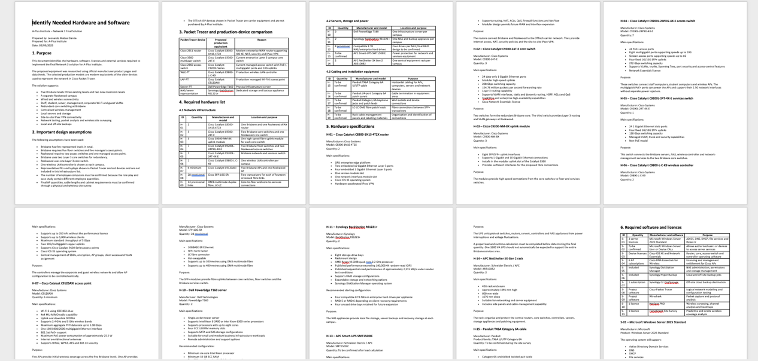  Summary of Clients network requirements  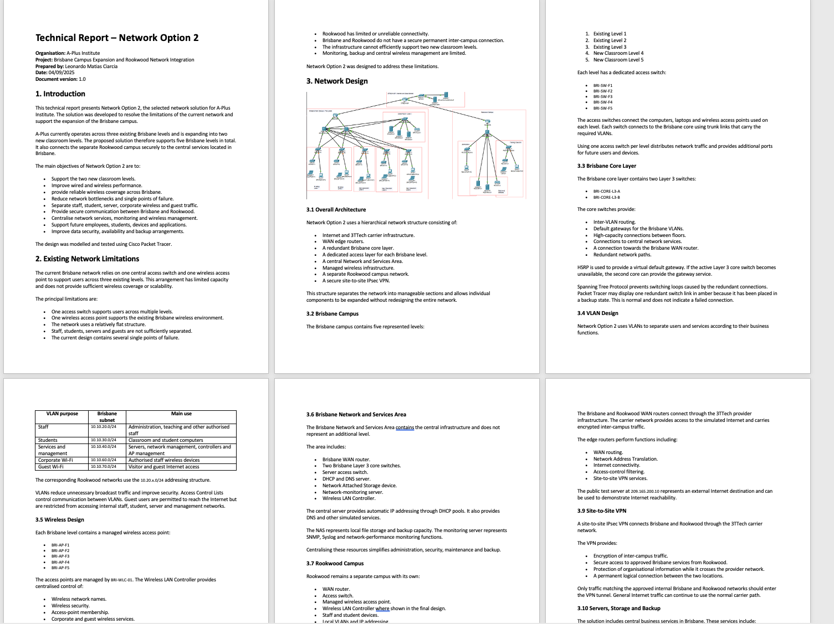  Technical Report  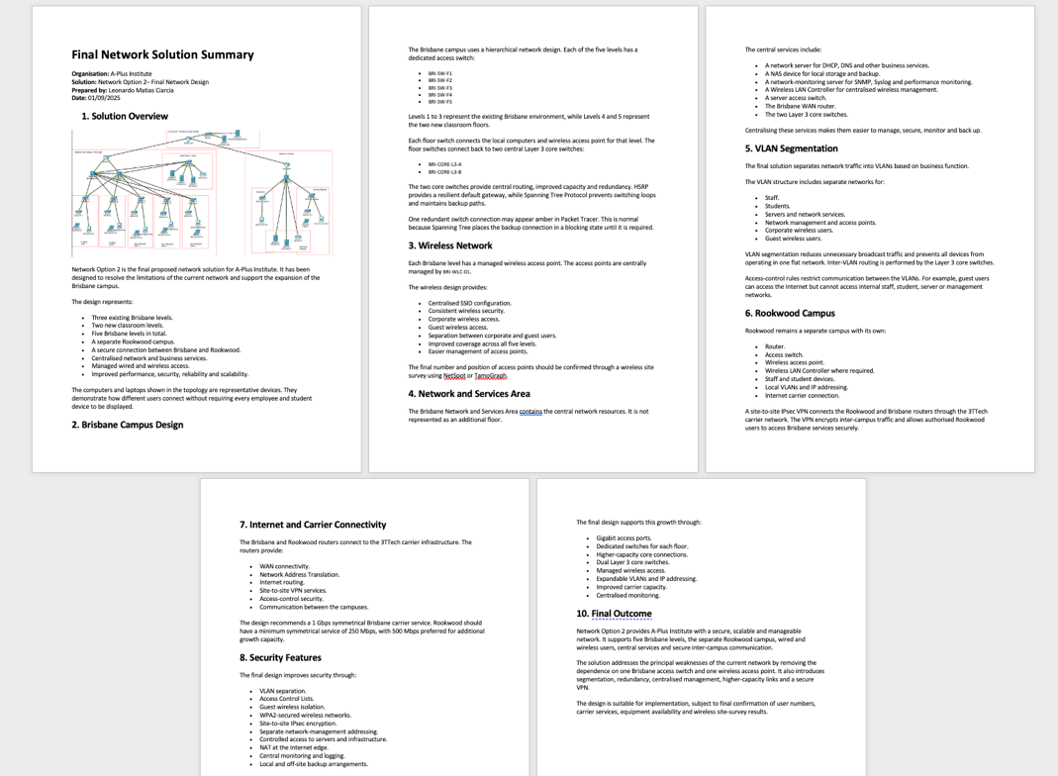  Design Documentation  These documents provide traceability from the original business requirements to the selected equipment, network configuration, testing results and final recommendation.  h) Network Option 2 is recommended as the optimum design for A-Plus Institute.  Although Network Option 1 has a lower initial cost, its single-router and single-trunk dependence, autonomous AP configuration and centralised service dependency create greater operational risk. It would require more significant changes as the organisation grows.  Network Option 2 requires a higher initial investment, but it provides better long-term value through:  - redundant Brisbane core switching;  - improved wireless coverage;  - controller-managed APs;  - separate functional VLANs;  - secure corporate and guest Wi-Fi;  - local services at both campuses;  - encrypted communication through the 3TTech VPN;  - improved monitoring and troubleshooting;  - easier expansion;  - reduced service disruption;  - better alignment with accepted enterprise network practices.  A staged implementation is recommended. Core infrastructure, security controls and essential connectivity should be installed first. Access switches, APs and additional services can then be deployed level by level. After implementation, connectivity, DHCP, VLANs, wireless coverage, redundancy, VPN operation and performance should be tested before final handover.  Conclusion  Both architecture options addressed the basic A-Plus requirements, but Network Option 2 provides the strongest balance of performance, security, scalability, availability and manageability. It converts the business requirements into a practical technical solution and provides a network architecture that can support the organisation’s current operations and future growth.  - Planning, managing, and implementing troubleshooting and monitoring strategies to ensure reliability and performance on advanced integrated internet protocol (IP) networks.  Demonstration requirements  Clearly explain to your assessor and project team:  - plan and monitor cluster 5 client’s {internet protocol (IP)} networks for performance and reliability.  - evaluate, design, and implement a troubleshooting structured plan.  - use network testing and monitoring tools.  - produce a maintenance plan for monitoring routing protocols and configurations for the same network.  - implement tests of advanced network solutions for the cluster 5 client network  Required: You must include screenshots/ pictures (and/ or videos) of your demonstration’s activities.  Response:  i.  The A-Plus Institute Network Option 2 was planned and monitored to ensure acceptable performance, availability and reliability across the Brisbane campus and the connection to the remote site. The monitoring plan covers wired users, wireless users, servers, switches, routers, VLANs, WAN links and network services.  The network is segmented using VLANs to reduce unnecessary broadcast traffic and improve performance. Corporate wireless clients use VLAN 60, guest wireless clients use VLAN 70, and servers and wireless infrastructure management use VLAN 40. Inter-VLAN routing is performed by the Brisbane Layer 3 core switches, while HSRP provides a resilient virtual gateway.  Performance was evaluated using connectivity, latency, packet-loss, DHCP, VLAN, trunk and wireless tests. Baseline results were recorded so that future results can be compared against normal network performance. Regular monitoring will help identify congestion, unavailable devices, abnormal response times, configuration faults and service interruptions before they significantly affect users.  monitoring table:  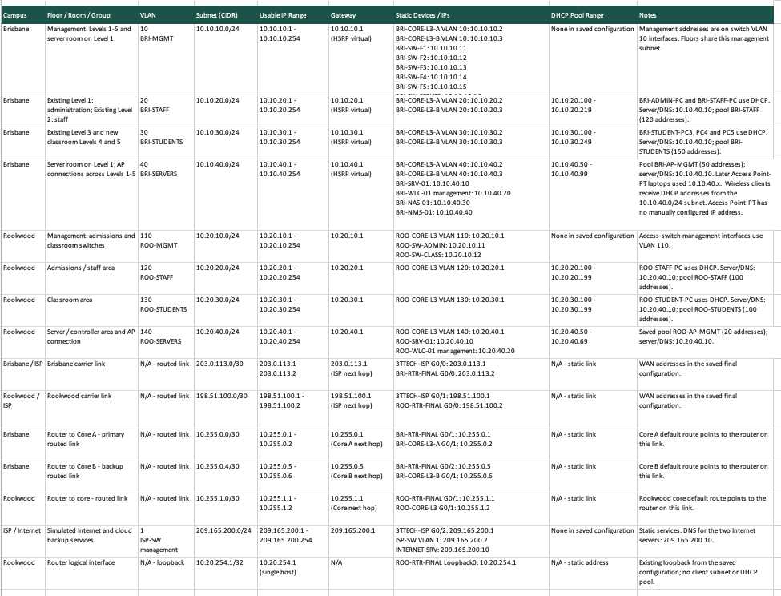  IP Schema network monitoring  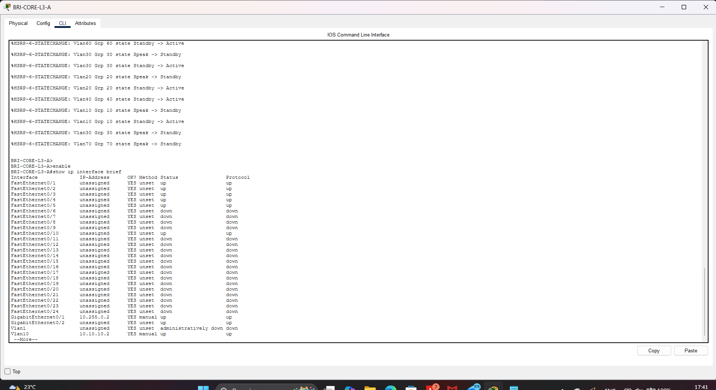  Show ip interface brief BRI-CORE-L3  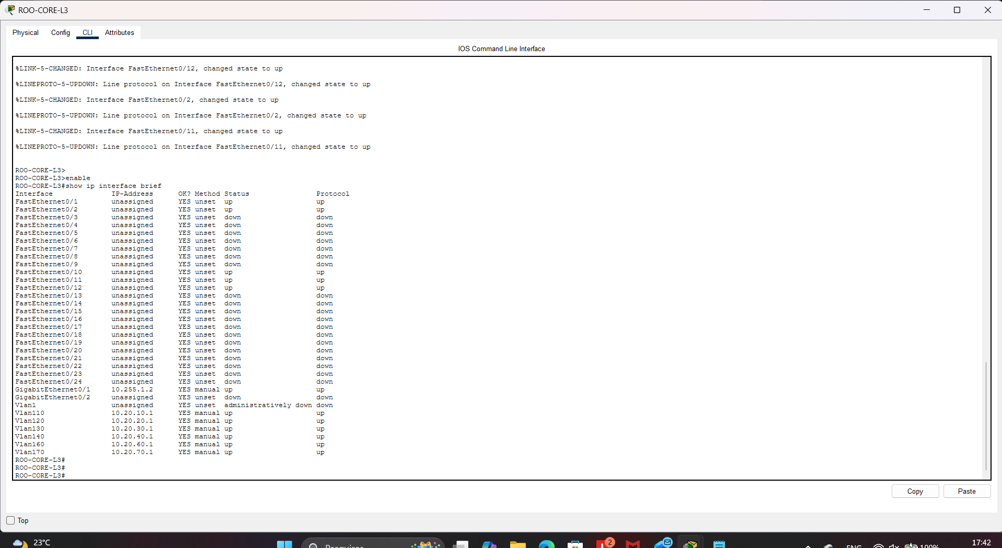  Show ip interface brief ROO-CORE-l3  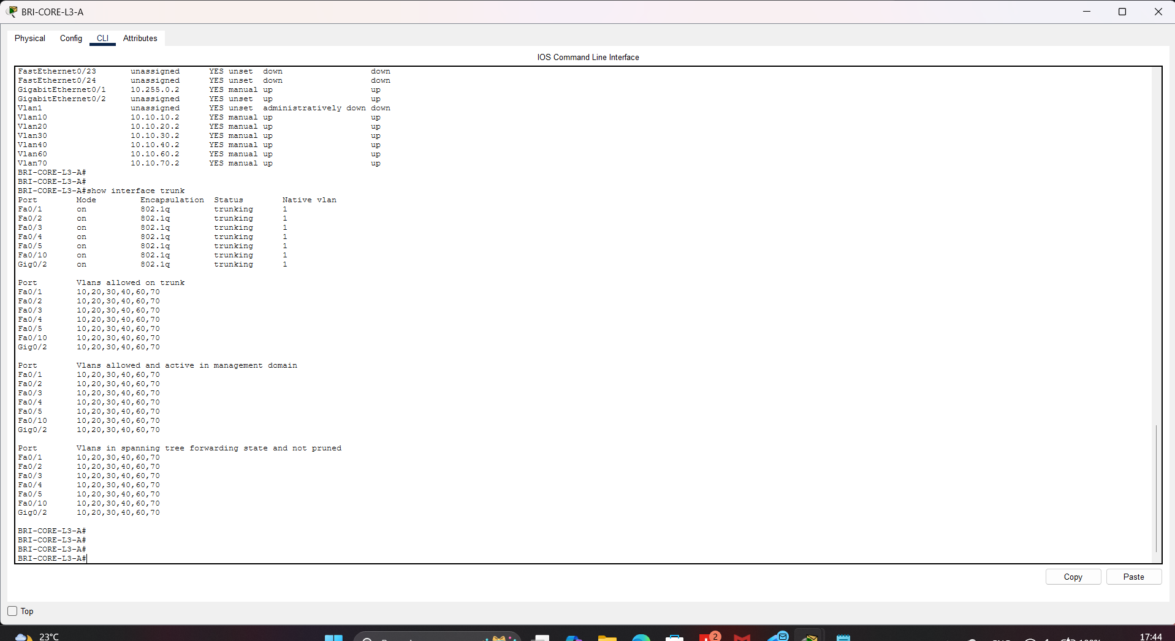  Show interface trunk BRI-CORE-L3  BRI-LAPTOP-F1 ipconfig showing 10.10.60.106 and successful ping results  BRI-WLC-01 showing Aps online  The monitoring evidence confirms that the required interfaces, VLANs and trunks were operational. The APlus-Secure wireless client received a valid VLAN 60 address and successfully reached its gateway, the internal server and the simulated external network.  ii.  A structured troubleshooting plan was developed for the A-Plus Institute Network Option 2. The plan follows a systematic process so that faults can be identified and corrected without creating unnecessary disruption.  First, information is collected from users, monitoring records, device status and error messages. The reported symptoms and affected devices are documented. The physical layer is then checked, including power, cables, port status and wireless association. The data-link layer is checked by examining VLAN membership, trunk configuration and Spanning Tree Protocol. The network layer is checked by confirming IP addresses, subnet masks, default gateways, routing and HSRP status. Network services such as DHCP, DNS and wireless authentication are then tested.  After the probable cause is identified, a corrective action is planned and its possible impact is evaluated. The configuration is backed up before significant changes are implemented. The affected service is then retested, the result is compared with the expected outcome, and the problem and resolution are recorded.  Table showing the structured procedure:  Troubleshooting record:  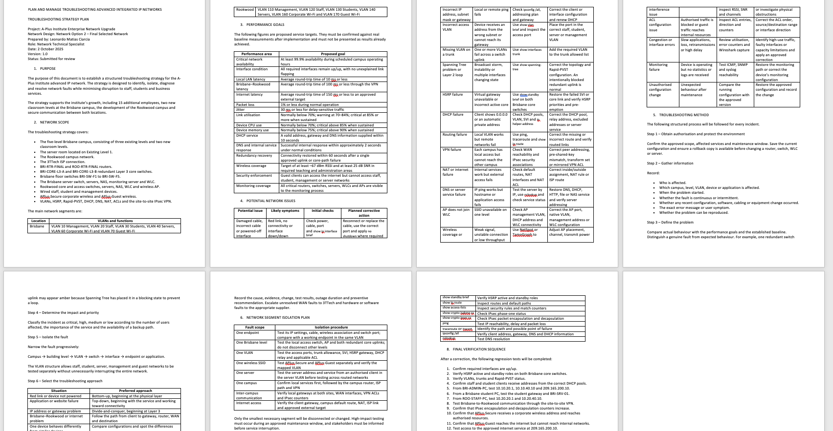  Plan and manage troubleshooting advanced integrated IP Network document  The structured process successfully identified that basic connectivity alone did not prove correct wireless VLAN assignment. After the AP connections were corrected, the client addressing and connectivity tests were repeated. This confirmed both network functionality and correct VLAN segmentation.  iii.  Different network testing and monitoring tools were used because no single tool provides all the information required to assess the A-Plus network. Cisco Packet Tracer was used to model the final topology, configure devices and test VLANs, routing, DHCP, wireless connectivity and packet flow. Packet Tracer Simulation mode was used to observe ICMP traffic across the network.  Wireshark was selected for packet-level analysis, including examination of protocols, source and destination addresses, DHCP exchanges and network errors. NetSpot and TamoGraph were used for wireless site-survey activities, including signal-strength analysis, access-point detection, coverage assessment and identification of possible interference.  Cisco IOS diagnostic commands were also used to confirm interface, VLAN, trunk, STP, routing and gateway status. The results from these tools were compared with the planned network requirements to determine whether the solution operated correctly.  Table show all the tools used in this project:  iv.  A maintenance plan was prepared to keep the A-Plus Institute routing environment reliable, secure and recoverable. The plan covers router and Layer 3 switch interfaces, inter-VLAN routing, HSRP gateway redundancy, WAN routes, remote-site connectivity, device configurations and IOS maintenance.  Routine checks will confirm that routing information remains correct, redundant gateways are available, interfaces are operational and configurations are saved. Backups will be created before and after approved changes. IOS updates will only be installed after compatibility and security requirements are reviewed, the configuration is backed up, the change is approved and a rollback procedure is prepared.  Maintenance activities will be scheduled outside teaching and business hours where possible. Every change will be documented with the date, device, reason, technician, configuration change, test result and approval information.  Maintenance schedule table:  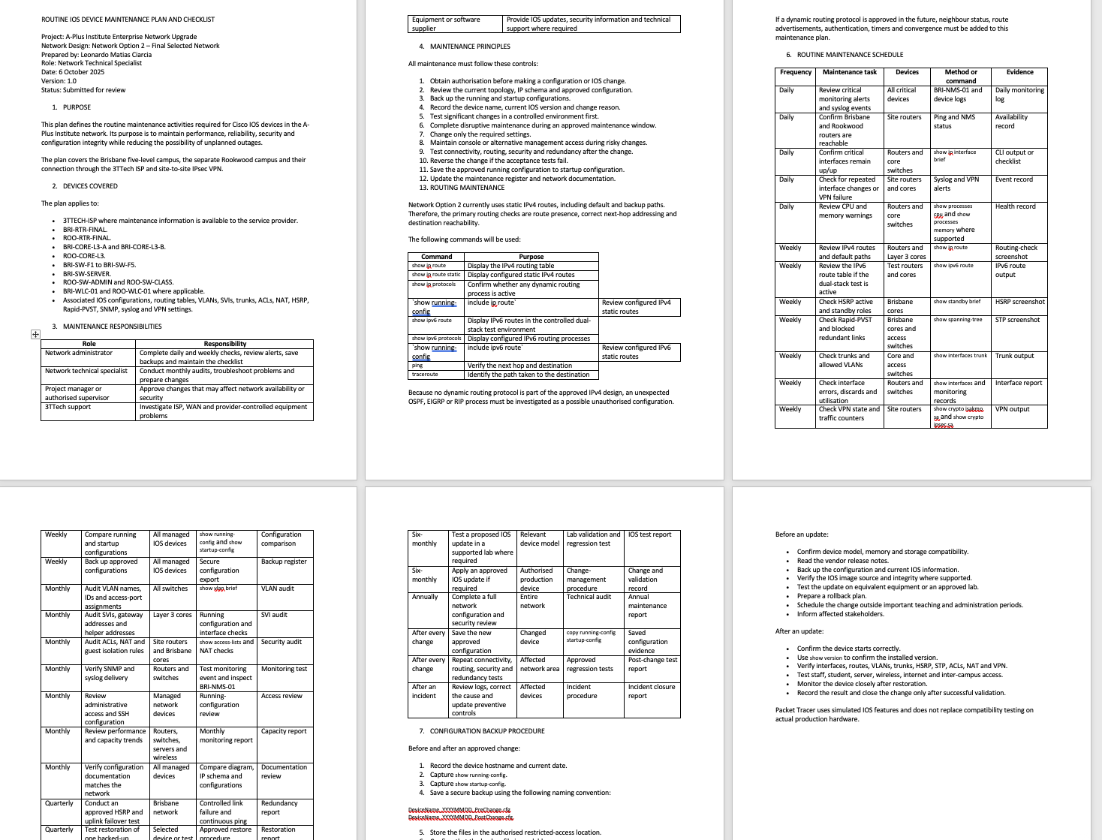  Routine IOS device maintenance plan and checklist document  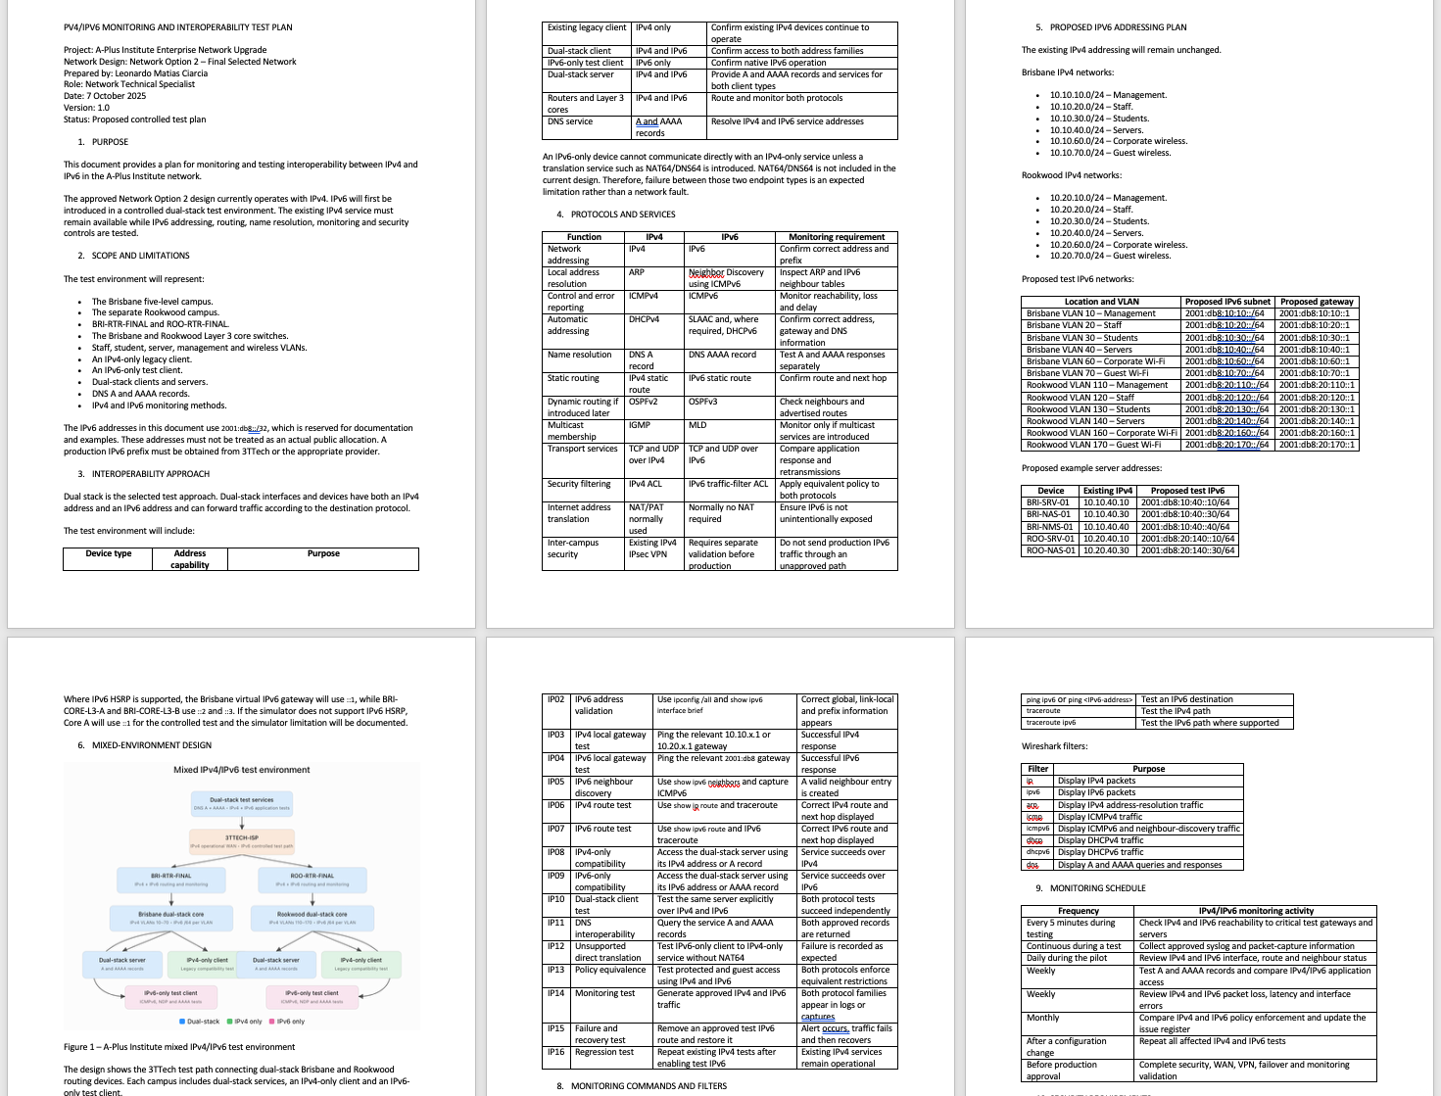  IPV4/IPV6 monitoring and interoperability test plan  Before a routing or IOS change, the current running configuration will be reviewed and saved to startup configuration. A separate backup will be retained, and the affected interfaces and routes will be documented. If the change causes loss of connectivity or an unexpected result, the previous commands or saved configuration will be restored. Connectivity, routing, HSRP and network services will then be retested.  v.  The advanced network solution tests were implemented in Cisco Packet Tracer using A-Plus Institute’s Network Option 2. Testing covered VLAN segmentation, inter-VLAN routing, DHCP, switch trunks, wireless VLAN assignment, HSRP gateway redundancy, STP, internal connectivity, remote connectivity and external connectivity.  Each test included a defined purpose, procedure, expected result and actual result. Any unexpected result was investigated through the structured troubleshooting process and the test was repeated after correction. The final results demonstrated that the proposed network supported reliable wired and wireless communication, appropriate segmentation and resilient network services.  Table showing the test maded:  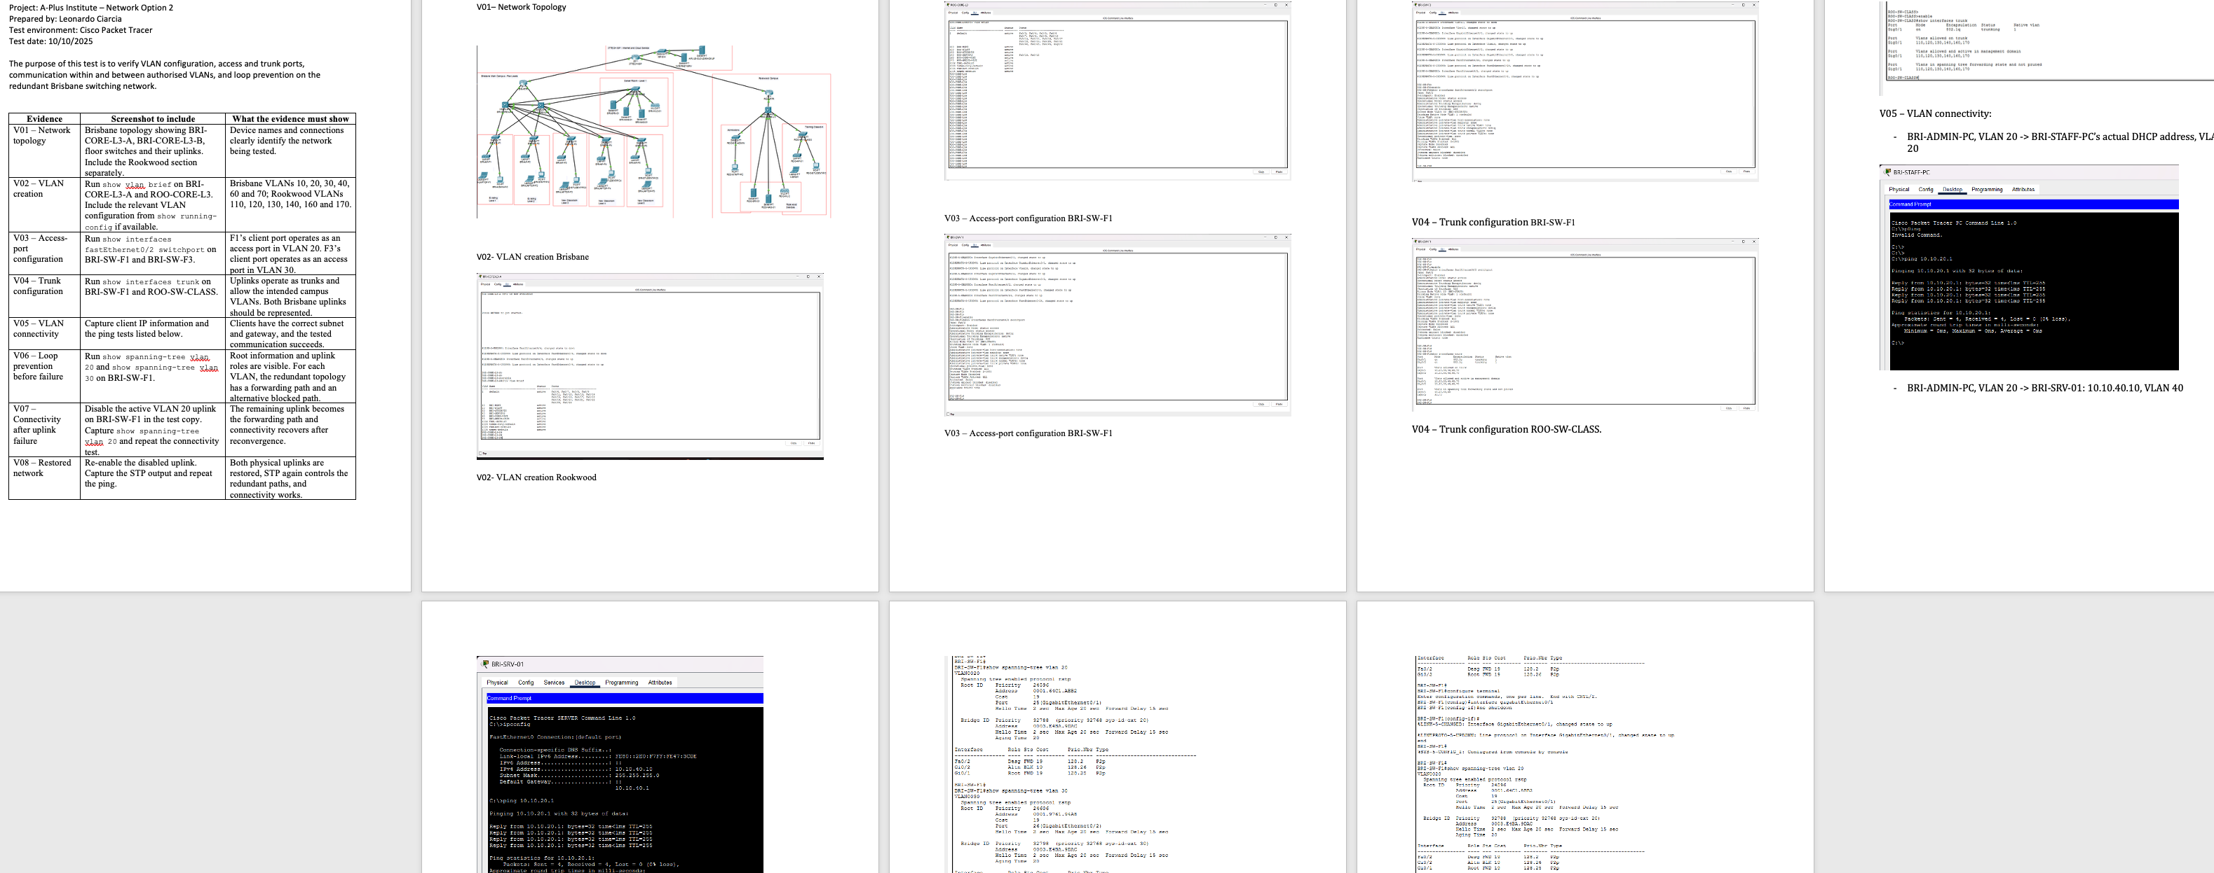  Test VLAN connectivity document  The implemented tests confirmed that the A-Plus Institute Network Option 2 met the planned functional and performance requirements. The VLANs, trunk links, routed interfaces, redundant gateways and wireless infrastructure operated as designed. Corporate wireless clients were assigned to VLAN 60, while AP and WLC management remained in VLAN 40. Successful internal and external connectivity tests confirmed that the final network solution was operational. Test results and screenshots were retained as evidence, and the final configuration was saved for future maintenance and recovery. | ☐ | ☐
  Practical component | Lab implementation
  ISP CPE | ISP router/ONT, normally 192.168.1.1
  Edge router | Cisco 1800 router configured as home-router
  Layer 3 switch | Cisco 3560 configured as home-switch
  Wired workstations | Laptop/PC connected to VLAN 10
  Wireless network | Access point connected to VLAN 20
  Wireless/mobile device | Laptop or phone connected through the AP
  Other client device | Printer or another end device connected to VLAN 30
  WAN | ISP CPE to Cisco router
  LAN | Cisco router to Layer 3 switch
  Services | VLANs, DHCP, DNS, routing, NAT/PAT and internet access
  Monitoring | Cisco verification commands, ping, tracert and browser tests
  Troubleshooting | Interface, VLAN, route, DHCP and connectivity verification
  Network area | Interface or gateway | Address
  ISP network | ISP CPE | 192.168.1.1/24
  Router WAN | FastEthernet0/0 | 192.168.1.2/24
  Router LAN | FastEthernet0/1 | 192.168.100.1/24
  Switch routed uplink | Port connected to router | 192.168.100.2/24
  VLAN 10 – PCs | SVI/default gateway | 10.10.10.1/24
  VLAN 20 – Wi-Fi | SVI/default gateway | 10.10.20.1/24
  VLAN 30 – Printer | SVI/default gateway | 10.10.30.1/24
  Regulation or legislation | Relevance to A-Plus Institute | Incorporation into the design and policies
  Telecommunications Act 1997 | Provides the main Australian regulatory framework for telecommunications services and carriers. | Use authorised service providers, document carrier connections and ensure network equipment is used in accordance with applicable requirements.
  Privacy Act 1988 and Australian Privacy Principles | Applies to the handling and protection of personal information where the organisation is covered by the Act. APP 11 concerns reasonable protection from misuse, interference, loss and unauthorised access. | VLAN separation, authentication, access controls, encrypted administration, secure Wi-Fi, logging, patching, backups and an incident-response procedure.
  Notifiable Data Breaches scheme | Requires covered organisations to assess eligible data breaches and notify affected individuals and the OAIC where the legal threshold is met. | Establish incident identification, escalation, assessment, containment and notification procedures.
  Disability Discrimination Act 1992 | Prohibits discrimination based on disability, including in education and access to services. | Provide reliable coverage, accessible digital systems, suitable device connectivity and reasonable access arrangements for users with disabilities.
  Work Health and Safety Act 2011 (Queensland) | Requires work risks to be managed during installation, maintenance and testing. | Complete risk assessments, control trip hazards, manage cables, use safe lifting techniques, restrict access to work areas and use appropriate equipment.
  Electrical Safety Act 2002 (Queensland) | Relevant when installing and working around powered networking equipment. | Inspect leads and power supplies, avoid overloaded outlets and ensure electrical work is performed by authorised personnel where required.
  Copyright Act 1968 | Protects software, documentation and other licensed materials. | Use appropriately licensed operating systems, firmware, applications and technical documentation.
  Test performed | Expected result | Final result
  Connect laptop to APlus-Secure | Successful WPA2-PSK/AES association | Passed
  Verify corporate laptop DHCP address | Address from 10.10.60.0/24 | Passed
  Ping 10.10.60.1 | VLAN 60 gateway responds | Passed
  Ping 10.10.40.10 | VLAN 40 server responds | Passed
  Ping 209.165.200.10 | External destination responds | Passed
  Check AP trunk configuration | Fa0/24 carries VLANs 40, 60 and 70 | Passed
  Check WLC AP status | Five Brisbane APs online | Passed
  Packet Tracer simulation | Successful ICMP exchange | Passed
  Specification | Final Network Option 2
  Server and infrastructure VLAN | VLAN 40
  Server and infrastructure subnet | 10.10.40.0/24
  WLC management address | 10.10.40.20
  AP management | VLAN 40
  Corporate SSID | APlus-Secure
  Corporate wireless VLAN | VLAN 60
  Corporate wireless subnet | 10.10.60.0/24
  Corporate wireless gateway | 10.10.60.1
  Guest SSID | APlus-Guest
  Guest wireless VLAN | VLAN 70
  Guest wireless subnet | 10.10.70.0/24
  Guest wireless gateway | 10.10.70.1
  Address allocation | DHCP
  Wireless security | WPA2-PSK with AES
  AP switching mode | Local switching with central authentication
  AP switch ports | Fa0/24 trunks on BRI-SW-F1 through BRI-SW-F5
  Component category | Purpose
  ISP CPE and enterprise router | Provide carrier and WAN connectivity
  BRI-CORE-L3-A and BRI-CORE-L3-B | Provide redundant core switching and inter-VLAN routing
  Managed access switches | Connect access points and wired end devices
  Wireless LAN controller | Centrally configure and monitor access points
  Enterprise wireless access points | Provide wireless coverage and user capacity
  Cat6 structured cabling | Connect devices and provide reliable Ethernet access
  Fibre/SFP uplinks | Provide high-speed connections between network layers
  UPS equipment | Protect core, switching and wireless equipment from power interruptions
  Racks and patch panels | Organise and protect network infrastructure
  Packet Tracer | Model and simulate the proposed network
  NetSpot and TamoGraph | Measure coverage, signal strength and interference
  Wireshark and Cisco diagnostic commands | Support monitoring and troubleshooting
  CLIENT PROJECT SIGN-OFF FORM
  DEMONSTRATION
  Dear Dijo,
  This is to sign-off completion of your project with us. Kindly complete as best as possible and send back to us.
  PROJECT NAME: Network Solution ICTTEN622 | PROJECT MANAGER: Leonardo Matias Ciarcia
  START DATE: 01/09/2025 | COMPLETION DATE: 22/09/2025
  PROJECT DURATION: 210 hours | SPONSOR: Dijo
  PROJECT GOAL:
  - ﻿﻿Enterprise Network Upgrade
  - ﻿﻿Wireless LAN Coverage
  - ﻿﻿Improved Networking Security & Performance
  - ﻿﻿Sustainability Goals
  - ﻿﻿Compatibility with existing infrastructure
  PROJECT DELIVERABLES:
  - ﻿﻿future-proof, high capacity, secure and scalable enterprise network
  - ﻿﻿2 new floors equipped with high-perfomance enterprise WLAN
  - ﻿﻿Stable, fast Internet
  - ﻿Secure data transmission
  - ﻿﻿Sustainable and energy-efficient technologies, hardware with lower power consumption
  BY SIGNING THIS DOCUMENT, I ACKNOWLEDGE THAT I HAVE DELIVERED ALL THE STATED DELIVERABLES | BY SIGNING THIS DOCUMENT, I ACKNOWLEDGE THAT I HAVE DELIVERED ALL THE STATED DELIVERABLES.
  PROJECT MANAGER NAME AND SIGNATURE:   | SPONSOR NAME AND SIGNATURE:  
  DATE:  | DATE:  
  Client requirement | How Network Option 2 meets the requirement
  Reliable connectivity | Managed switches, planned AP placement and tested uplinks provide stable connectivity.
  Coverage across the expanded premises | APs are planned across all five levels, with two APs per level considered in the detailed wireless plan.
  Support for students and staff | DHCP and scalable addressing support multiple authorised user groups and devices.
  Wireless mobility | Overlapping AP coverage and central management allow users to move between coverage areas.
  Security | Secure Wi-Fi, VLAN separation, ACLs, authentication and encrypted management protect the network.
  Separation of user groups | VLANs isolate wireless, student, staff, administrative and other network services.
  Internet access | Routing, WAN connectivity and NAT/PAT provide controlled external access.
  Central administration | The wireless controller and managed network devices simplify configuration and monitoring.
  Network availability | Redundant core switches and alternative network paths reduce single points of failure.
  Performance | Site-survey findings, suitable AP placement, channel planning and traffic monitoring reduce congestion and interference.
  Online learning and video services | Improved switching and wireless capacity support cloud applications, learning platforms and video conferencing.
  Accessibility | Reliable coverage and support for different devices assist users in accessing digital learning services.
  Future users and devices | Additional switch ports, APs, DHCP capacity and VLANs can be added without redesigning the complete network.
  Future technologies | The structured and modular design can support newer wireless standards, IPv6, improved security and additional cloud services.
  Monitoring and troubleshooting | Packet Tracer, Wireshark, NetSpot, TamoGraph and Cisco diagnostic commands support ongoing performance management.
  Budget control | The two design options and component comparison allowed the client to evaluate cost against performance and long-term value.
  VLAN | Purpose | Brisbane subnet
  10 | Network management | 10.10.10.0/24
  20 | Staff | 10.10.20.0/24
  30 | Students | 10.10.30.0/24
  40 | Servers | 10.10.40.0/24
  60 | Corporate Wi-Fi | 10.10.60.0/24
  70 | Guest Wi-Fi | 10.10.70.0/24
  Software | Use
  Cisco Packet Tracer | Created, configured and simulated both network designs
  NetSpot | Detected wireless networks, signal levels and channel information
  TamoGraph | Produced site-survey measurements and wireless coverage maps
  Wireshark | Supported packet analysis and network troubleshooting
  PuTTY | Provided console access to the physical Cisco equipment
  Floor-plan software/document tools | Recorded AP positions, cabling routes and infrastructure
  Client specification | Industry practice applied
  Support five Brisbane levels | Hierarchical and modular network design
  Reliable network services | Dual core switches and redundant uplinks
  Improved wireless coverage | Site survey and planned AP placement
  Support staff, students and guests | Separate VLANs and SSIDs
  Protect administrative information | ACLs, authentication and segmentation
  Secure inter-campus communication | Site-to-site IPsec VPN
  Central wireless control | Wireless LAN controller and managed APs
  Support future growth | Scalable switches, subnets, APs and fibre uplinks
  Reduce network loops | Spanning Tree Protocol and controlled redundant paths
  Protect device administration | SSH, secure passwords and restricted management VLAN
  Maintain service availability | Local server/NAS resources and configuration backups
  Monitor performance | NMS, logs, diagnostic commands and scheduled testing
  Follow cabling standards | Cat6 access cabling and OM4 fibre uplinks
  Provide safe implementation | WHS risk controls and organised cabling
  Business requirement | Technical design
  Expansion to five Brisbane levels | One access-switching area per level with planned AP coverage
  More students and devices | PoE access switches, larger DHCP pools and scalable VLANs
  Reliable learning services | Redundant core switches and alternative uplink paths
  Secure staff and student access | Separate staff, student, corporate Wi-Fi and guest VLANs
  Wireless mobility | Managed APs using consistent SSID and security policies
  Protect servers and records | Dedicated server VLAN, ACLs, backups and restricted access
  Connect Brisbane and Rookwood | Encrypted 3TTech site-to-site VPN
  Reduce downtime at Rookwood | Local server and NAS resources
  Simplify administration | WLC, NMS, standard device names and documented addressing
  Control project cost | Comparison of two options, quotations and phased implementation
  Support future technology | Modular architecture, fibre uplinks and IPv4/IPv6 planning
  Component | Metric monitored | Tool or command | Acceptable result | Frequency
  Core switches | Interface and VLAN status | show ip interface brief | Required interfaces are up/up | Daily
  Switch trunks | Trunk and VLAN status | show interfaces trunk | Required VLANs allowed and forwarding | Weekly
  VLANs | VLAN availability and port assignment | show vlan brief | Correct VLANs active | Weekly
  Redundant gateway | HSRP state | show standby brief | One active and one standby device | Weekly
  Local connectivity | Reachability and packet loss | ping | Successful replies and no packet loss | Daily
  WAN connection | Remote/external reachability | ping and tracert | Destination reachable | Daily
  DHCP | Address allocation | Client ipconfig | Correct subnet and gateway received | Daily
  Wireless network | SSID, AP and client connection | WLC and laptop configuration | APs online and correct VLAN assigned | Daily
  STP | Loop-prevention status | show spanning-tree | Stable root and forwarding state | Monthly
  Device performance | CPU and memory | show processes cpu, show memory | No sustained resource exhaustion | Weekly
  Configuration | Saved configuration | show running-config and show startup-config | Configuration current and backed up | After changes
  Stage | Action
  1. Identify | Record the problem, affected users, time, symptoms and error messages
  2. Establish scope | Determine whether the issue affects one device, one VLAN, one level or the entire network
  3. Collect information | Check IP details, device status, logs, topology and recent changes
  4. Develop probable causes | Consider physical, VLAN, trunk, DHCP, routing, wireless and security faults
  5. Test the cause | Use commands and tools without unnecessarily affecting users
  6. Plan the correction | Select the safest solution and prepare rollback actions
  7. Implement | Apply the approved corrective action
  8. Retest | Repeat the original test and related connectivity tests
  9. Document | Record the cause, action, result and recommendations
  Troubleshooting record | Details
  Reported problem | APlus-Secure laptop received a VLAN 40 address instead of VLAN 60
  Initial observation | The laptop could ping network destinations, but its subnet was incorrect
  Probable cause | Wireless traffic was entering the AP-management VLAN
  Investigation | Checked SSID mapping, WLC status, DHCP, VLAN 60, trunks and AP association
  Identified cause | AP ports did not carry the corporate wireless VLAN under local switching
  Corrective action | Changed all Brisbane AP ports Fa0/24 to trunks with native VLAN 40 and allowed VLANs 40, 60 and 70
  WLC setting | APlus-Secure retained VLAN 60 and used local switching with central authentication
  Retest | Renewed the laptop DHCP configuration and repeated connectivity tests
  Expected final result | Laptop receives 10.10.60.x and successfully reaches required destinations
  Status | Resolved after successful verification
  Tool | Purpose in the project | Evidence
  Cisco Packet Tracer | Create and test Network Option 2 | Final .pkt topology screenshot
  Packet Tracer Simulation mode | Observe packet flow | Successful Simple PDU or ICMP screenshot
  IOS commands | Check VLANs, trunks, STP, interfaces and routing | CLI screenshots
  Wireshark | Inspect packets and protocols | Packet capture screenshot
  NetSpot | Identify Wi-Fi networks and signal conditions | Existing NetSpot evidence
  TamoGraph | Conduct the simulated site survey and coverage assessment | Existing Level 8/site-survey evidence
  Ping | Confirm reachability and packet loss | Successful ping screenshots
  Traceroute/tracert | Display the path to a destination | Command output screenshot
  ipconfig | Confirm DHCP, subnet and gateway assignment | Laptop configuration screenshot
  Maintenance activity | Command or method | Frequency | Action if unsuccessful
  Check routed interfaces | show ip interface brief | Daily | Investigate down interfaces
  Check routing table | show ip route | Weekly | Verify routes and next hops
  Check HSRP redundancy | show standby brief | Weekly | Restore active/standby operation
  Check WAN reachability | Ping remote and external addresses | Daily | Check interfaces, routes and WAN links
  Check VLAN interfaces | show ip interface brief | Weekly | Verify SVI and VLAN status
  Review device configuration | show running-config | Monthly | Correct unauthorised or incorrect changes
  Save configuration | copy running-config startup-config | After every change | Repeat save and verify
  Back up configurations | Export and store approved copies | Monthly and before changes | Escalate backup failure
  Review IOS version | show version | Quarterly | Assess compatible upgrade
  Apply IOS/security updates | Approved maintenance process | When required | Use rollback procedure
  Review logs and errors | Device logs and monitoring records | Weekly | Investigate repeated faults
  Test redundancy | Controlled HSRP/failover test | Quarterly | Restore original state and troubleshoot
  Review documentation | Compare diagram, IP schema and configuration | Quarterly | Update documentation
  Test | Procedure | Expected result | Actual result
  VLAN verification | Run show vlan brief | Required VLANs exist and correct ports are assigned | Passed
  Trunk verification | Run show interfaces trunk | Required VLANs cross the trunk links | Passed
  AP-port verification | Check Fa0/24 on BRI-SW-F1–F5 | Native VLAN 40; VLANs 40, 60 and 70 allowed | Passed
  STP verification | Run show spanning-tree | Stable topology without switching loops | Passed
  HSRP verification | Run show standby brief | One active and one standby core gateway | Passed
  Corporate Wi-Fi DHCP | Connect to APlus-Secure | Laptop receives 10.10.60.x | Default Gateway 10.10.60.1
  Corporate gateway | Ping 10.10.60.1 | Successful | Passed
  Server access | Ping 10.10.40.10 | Successful | Passed
  External access | Ping 209.165.200.10 | Successful | Passed
  Guest DHCP | Connect to APlus-Guest | Client receives 10.10.70.x | Default Gateway 10.10.70.1
  Guest external access | Ping 209.165.200.10 | Successful | Passed
  Guest internal isolation | Ping protected internal networks | Requests blocked by security rules | Passed
  Simulation test | Send a Simple PDU | Successful packet delivery where authorised | Passed
  Configuration persistence | Save and reopen the file/configuration | Settings remain available | Passed
- Finalization of Assessment Completion: Part II
- Assessment Submission

Feedback:

